**Usage of primitive data type.**

**Program: //Krishna jaiswal76**

import java.util.Scanner;

public class Main

{

public static void main(String[] args) {

Scanner sc=new Scanner(System.in);

System.out.println("Krishna jaiswal76");

System.out.println("Enter an integer:");

int n=sc.nextInt();

System.out.println("The integer is"+n);

System.out.println("Enter float value :");

float m=sc.nextFloat();

System.out.println("Floating value is:"+m);

System.out.println("Enter the Boolean value:");

boolean t=sc.nextBoolean();

System.out.println("The boolean value is "+t);

}

**Print the integer enter by the user.**

**Program: //Krishna jaiswal76**

import java.util.Scanner;

class Main{

public static void main (String[]args)

{

Scanner sc=new Scanner(System.in);

System.out.println("Krishna jaiswal76");

System.out.println("Enter an integer:");

int n=sc.nextInt();

System.out.println("The integer is:"+n);

}

}

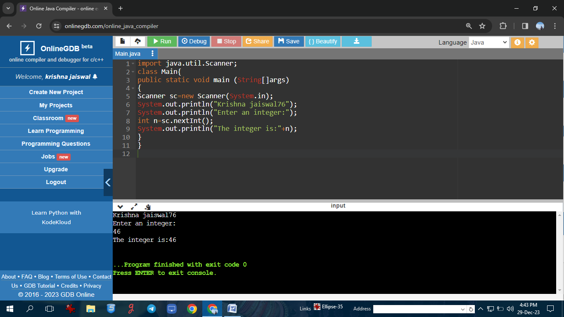

**Program of explicit type conversion.**

**Program: //Krishna jaiswal76**

public class ExplicitTypeConversionExample {

public static void main(String[] args) {

double doubleValue = 10.5;

int intValue = (int) doubleValue;

System.out.println("Krishna jaiswal76");

System.out.println("Double Value: " + doubleValue);

System.out.println("Int Value: " + intValue);

int intValue2 = 65;

char charValue = (char) intValue2;

System.out.println("Int Value 2: " + intValue2);

System.out.println("Char Value: " + charValue);

}}

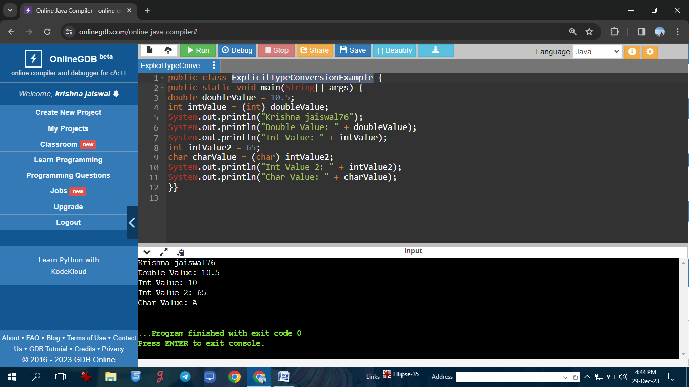

**Program of implicit type conversion**

**Program: //Krishna jaiswal76**

public class ImplicitTypeConversionExample {

public static void main(String[] args) {

int intValue = 5;

double doubleValue = intValue;

System.out.println("Krishna jaiswal76");

System.out.pritln("Int Value: " + intValue);

System.out.println("Double Value: " + doubleValue);

char charValue = 'A';

int intValue2 = charValue;

System.out.println("Char Value: " + charValue);

System.out.println("Int Value 2: " + intValue2);

}

}

**Demonstrate using instance/class variable in a java program by creating a simple**

**public class.**

**Program: //Krishna jaiswal76**

**p**ublic class Studentsrecords

{

public String name;

public Studentsrecords(String sname)

{

name = sname;

}

public void printstud()

{

System.out.println("Krishna jaiswal76");

System.out.println("Student Name: " + name );

}

public static void main(String args[])

{

Studentsrecords s = new Studentsrecords("Keshav");

s.printstud();

} }

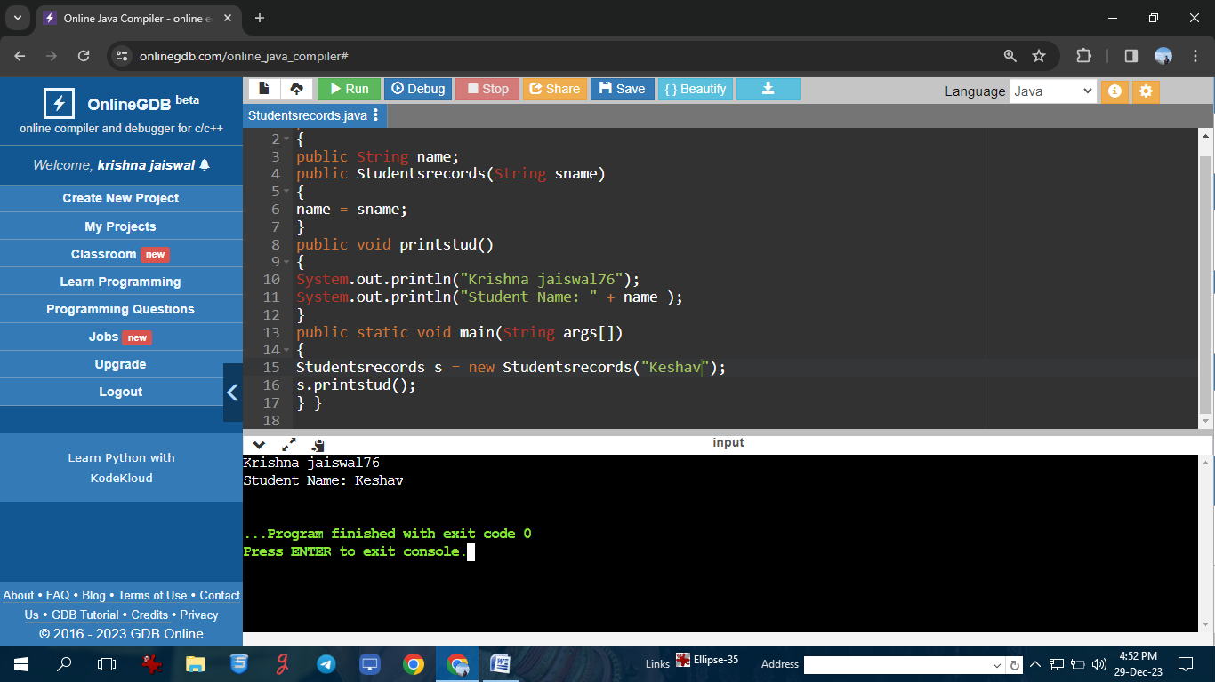

**Demonstrate the Java class using the getter setter method for accessing private**

**data members.**

**Program: //Krishna jaiswal76**

class Student{

private String name;

private int rollno;

public void setName(String n) {

name=n;

}

public String getName() {

return name;

}

public void setRollno(int r) {

rollno=r;

}

public int getRollno() {

return rollno;

}

}

public class Main{

public static void main(String[] args){

Student s1=new Student();

System.out.println("Krishna jaiswal76");

s1.setName("rohan sharma");

s1.setRollno(36);

System.out.println(s1.getName());

System.out.println(s1.getRollno());

}

}

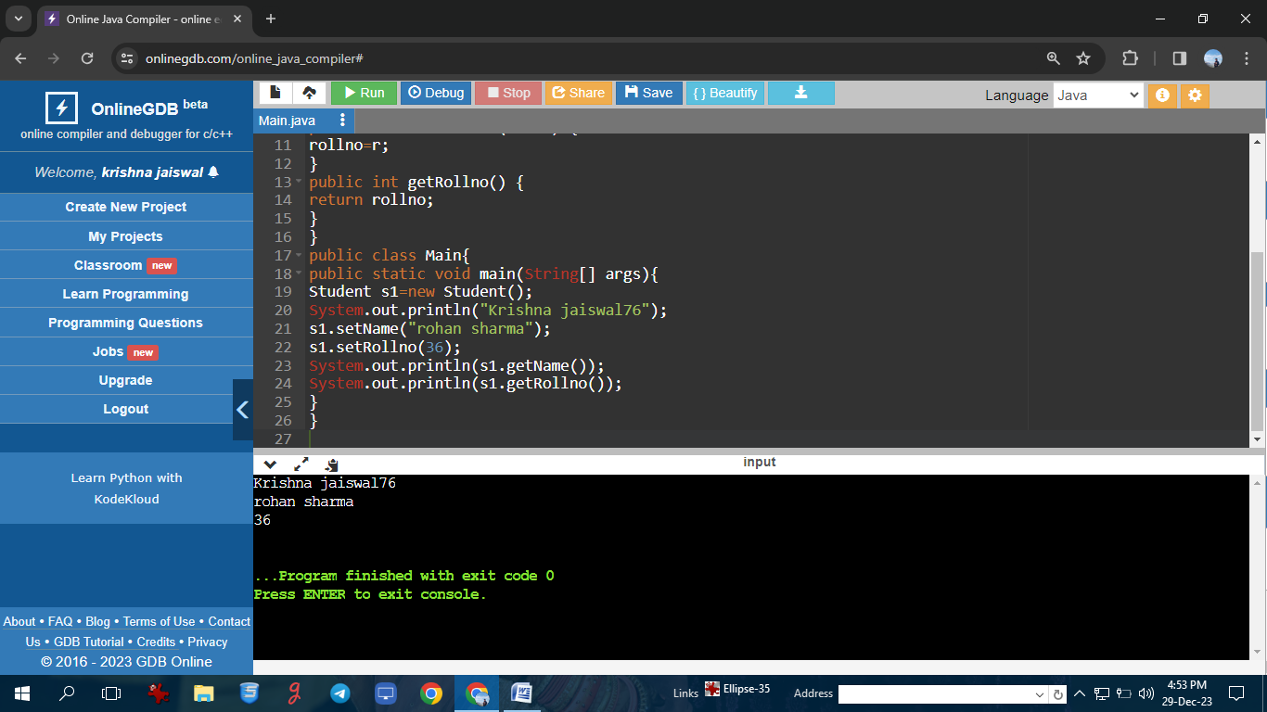

**Demonstrate creating class and instance(object)**

**Program: //Krishna jaiswal76**

class Student{

int id;

String name;

public static void main(String[] args)

{

Student s1=new Student();

System.out.println("Krishna jaiswal76");

System.out.println(s1.id);

System.out.println(s1.name);

}

}

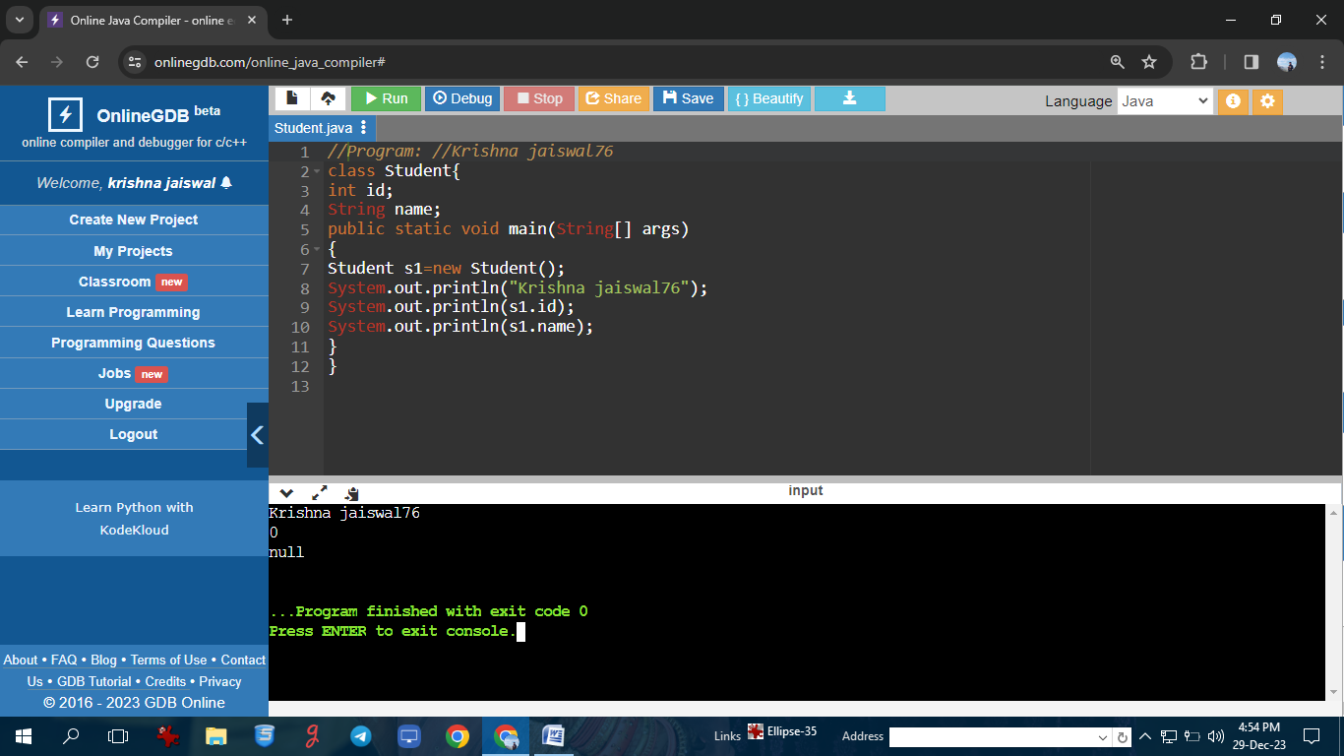

**To create the object in Java**

**Program: //Krishna jaiswal76**

// Step 1: Define a class

class Car {

String make;

String model;

int year;

public Car(String make, String model, int year) {

this.make = make;

this.model = model;

this.year = year;

}

public void displayInfo() {

System.out.println("Car Make: " + make);

System.out.println("Car Model: " + model);

System.out.println("Car Year: " + year);

}

}

public class ObjectCreationExample {

public static void main(String[] args) {

System.out.println("Krishna jaiswal76");

Car myCar = new Car("keshav", "Camry", 2022);

myCar.displayInfo();

}

}

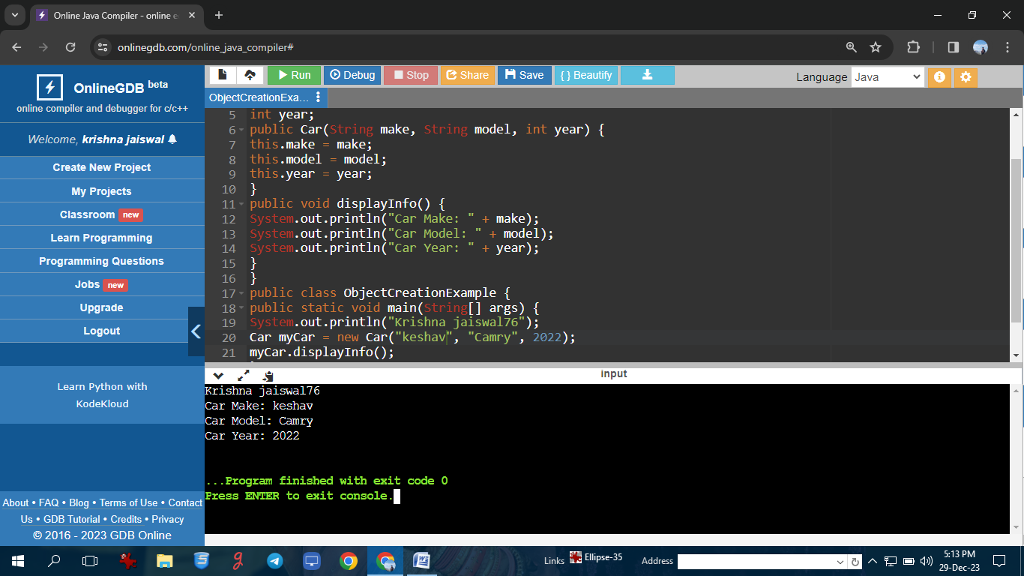

**Demonstrate the use of static variables.**

**Program: //Krishna jaiswal76**

class VariableDemo

{

static int count=0;

public void increment()

{

count++;

}

public static void main(String args[])

{

VariableDemo obj1=new VariableDemo();

VariableDemo obj2=new VariableDemo();

obj1.increment();

obj2.increment();

System.out.println("Krishna jaiswal76");

System.out.println("Obj1: count is="+obj1.count);

System.out.println("Obj2: count is="+obj2.count);

}

}

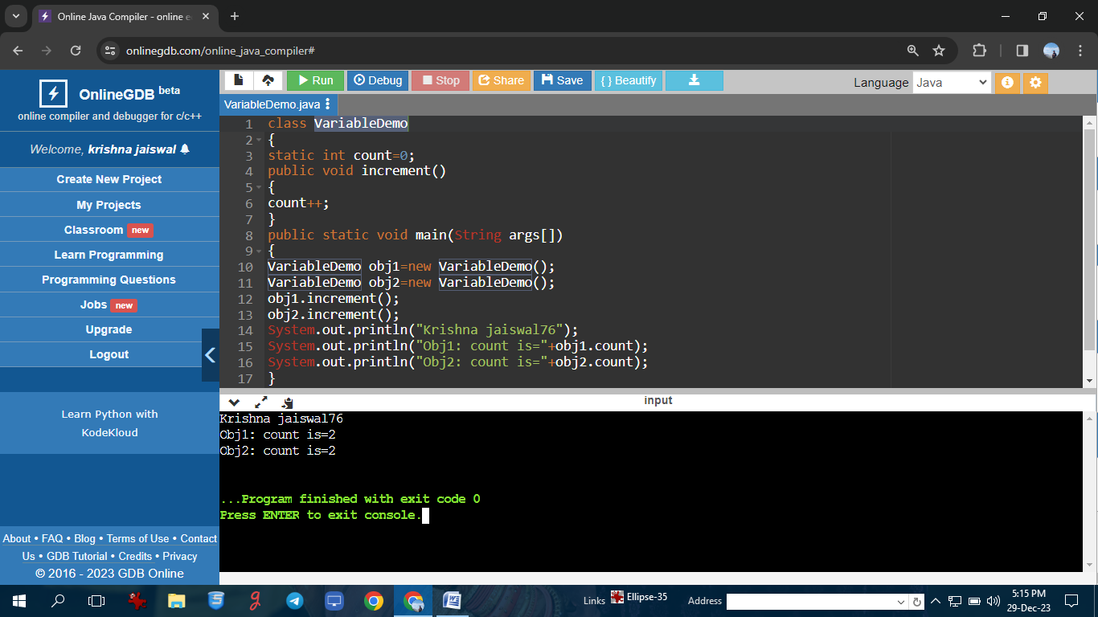

**Demonstrate the use of the static method.**

**Program: //Krishna jaiswal76**

class StaticTest {

// static method

static int add(int a, int b){

return a + b;

}

}

public class Main {

public static void main( String[] args ) {

StaticTest st = new StaticTest();

System.out.println("Krishna jaiswal76");

System.out.println(" 2 + 3 = " + StaticTest.add(2,3));

}

} 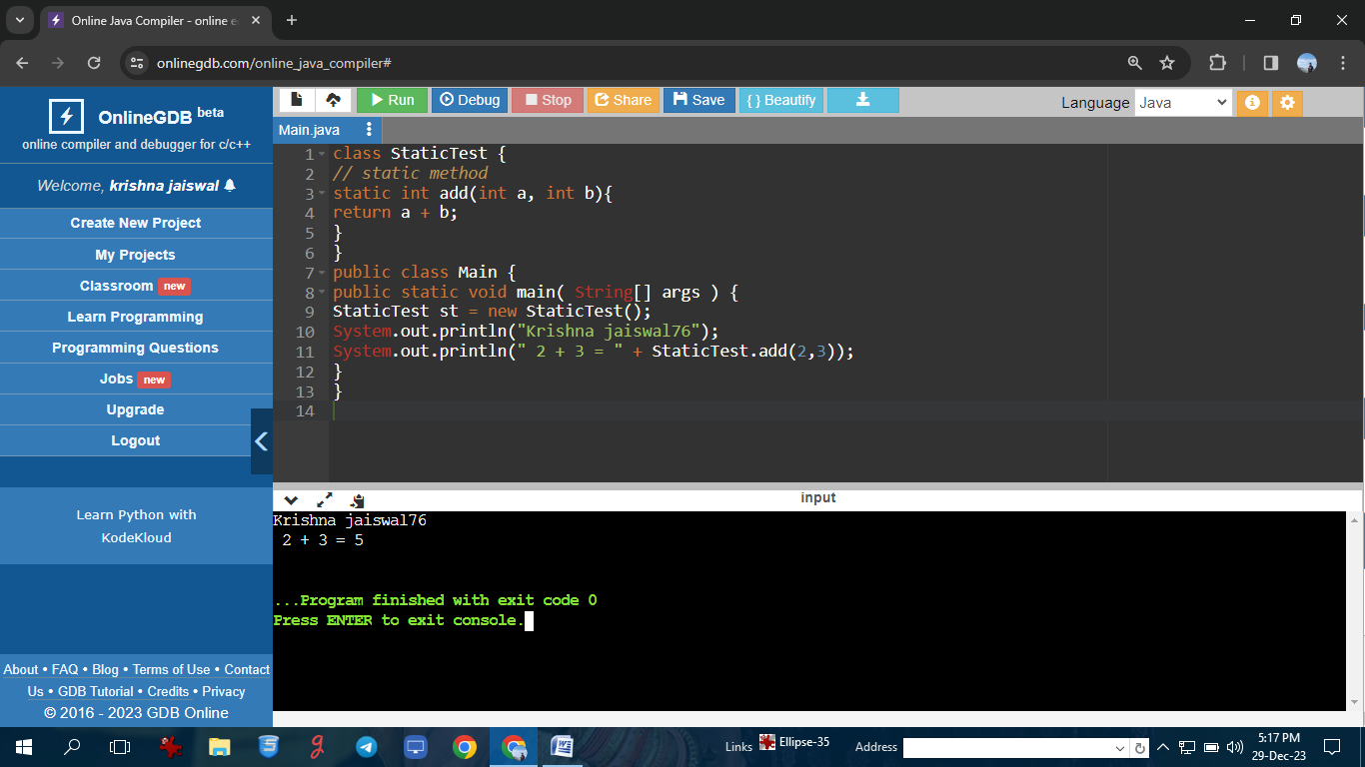

**To create a wrapper class program in Java (Autobixing)**

**Program: //Krishna jaiswal76**

// java program to convert primitive into objects

// autoboxing example of int to Integer

public class WrapperExample1{

public static void main(String args[]){

// converting int into Integer

int a=20;

Integer i=Integer.valueOf(a);

Integer j=a;

System.out.println("Krishna jaiswal76");

System.out.println(a+" "+i+" "+j);

}

}

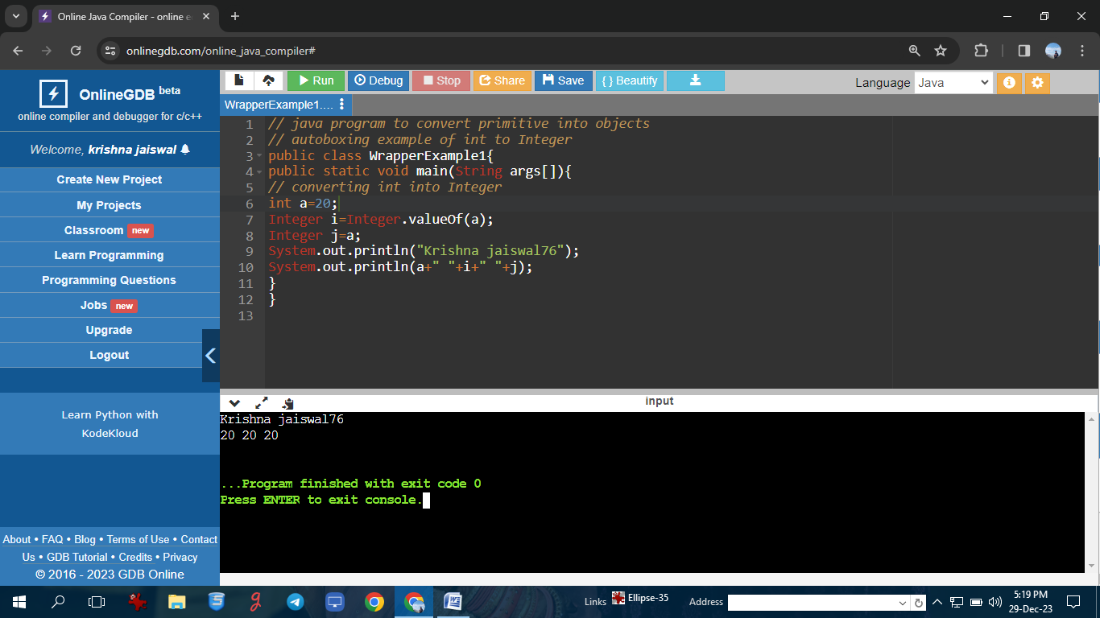

**To create a wrapper class program in Java (Unboxing)**

**Program: //Krishna jaiswal76**

//java program to convery object into primitives

// unboxing example of integer to integer

public class WrapperExample2{

public static void main(String args[]){

//converting integer to integer

Integer a= new Integer(3);

int i=a.intValue();

int j=a;

System.out.println("Krishna jaiswal76");

System.out.println(a+" "+i+" "+j);

}

}

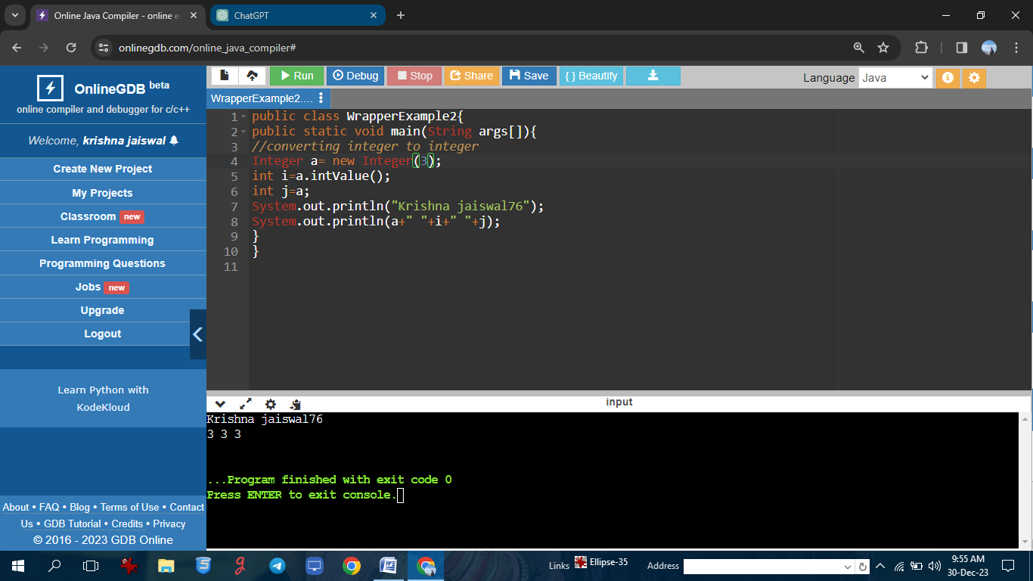

**Program of command line argument.**

**Program: //Krishna jaiswal76**

public class Main {

public static void main(String[] args) {

if (args.length == 0) {

System.out.println("Krishna jaiswal76");

System.out.println("No command line arguments provided.");

} else {

System.out.println("Command line arguments:");

for (int i = 0; i < args.length; i++) {

System.out.println("Argument " + (i + 1) + ": " + args[i]);

}

}

}

}

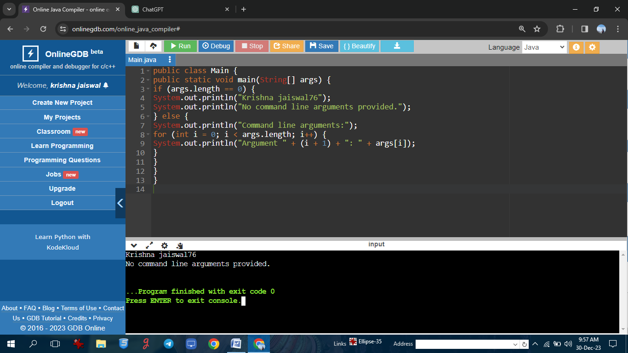

**Program of command line arguments**

**Program: //Krishna jaiswal76**

public class CommandLineArguments {

public static void main(String[] args){

if(args.length == 0){

System.out.println("Krishna jaiswal76");

System.out.println("No command-line argument");

}else{

System.out.println("command-line argument");

for(int i=0;i<args.length;i++){

System.out.println("argument"+(i+1)+":"+args[i]);

}

}

}

}

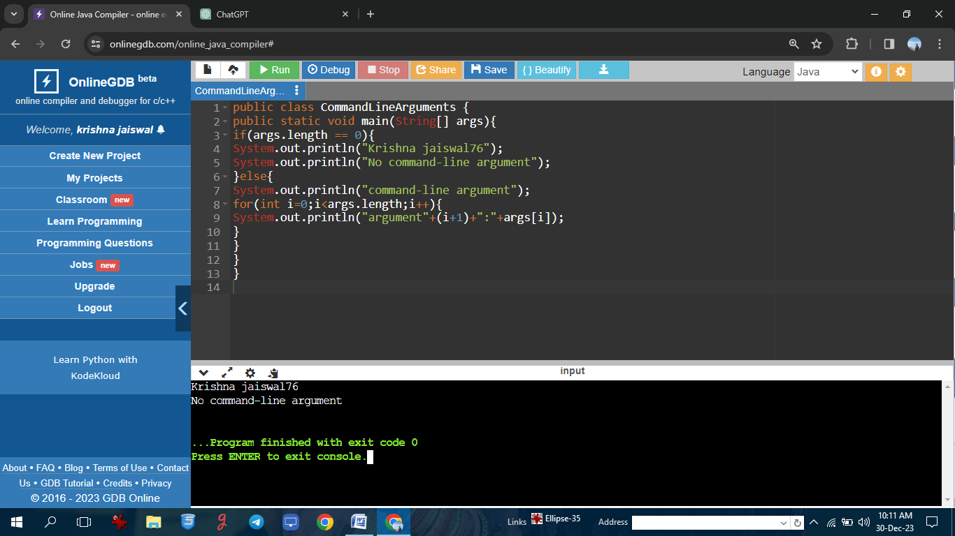

**Reverse the number(importing and making packages)**

**Program: //Krishna jaiswal76**

import java.util.Scanner;

public class Main{

public static void main(String[] args){

Scanner sc = new Scanner(System.in);

System.out.println("Krishna jaiswal76");

System.out.println("enter a number:");

int a = sc.nextInt();

int rev = 0,q;

while(a!=0){

q=a%10;

rev=(rev*10)+q;

a=a/10;

}

System.out.println("reverse of number is:"+rev);

}

}

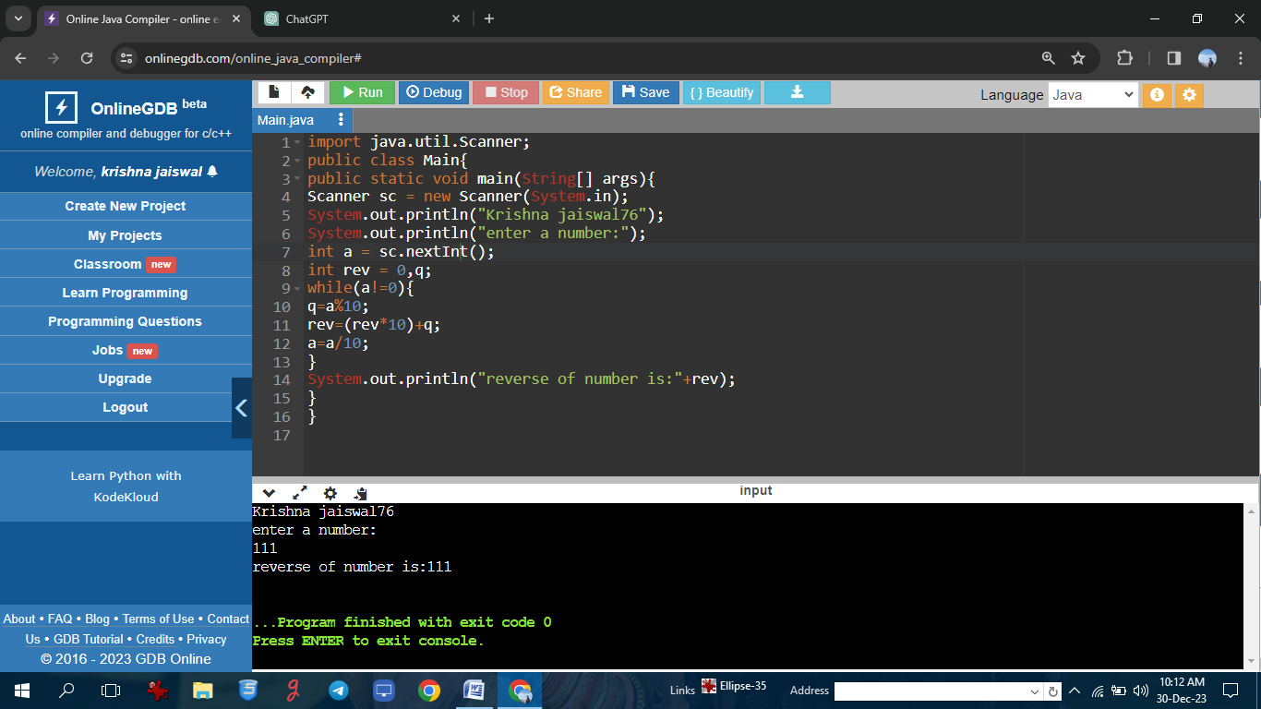

**Demonstrate the use of scanner class for taking input/output from user.**

Program: //Krishna jaiswal76

import java.util.Scanner;

public class A{

public static void main(String[] args){

Scanner sc=new Scanner(System.in);

System.out.println("Krishna jaiswal76");

System.out.println("Enter any number:");

int n=sc.nextInt();

System.out.println\\("The number is"+n);

}

}

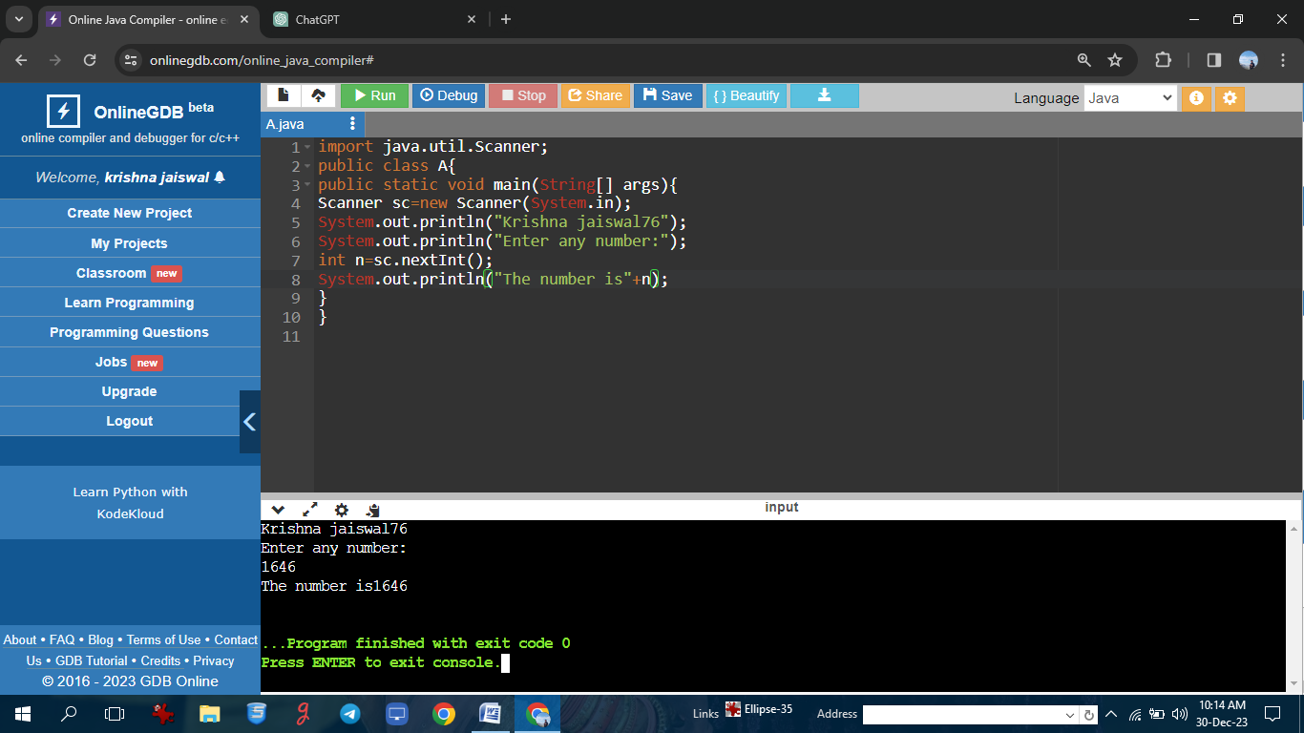

**Public access modifier program in Java**

**Program: //Krishna jaiswal76**

**public class LinearSearchExample{**

public static int LinearSearch(int[]arr,int key){

for(int i=0; i<arr.length; i++){

if(arr[i]==key){

return i;

}

}

return-1;

}

public static void main(String[] args){

int[]a1= {10,20,30,50,70,90};

int key=50;

System.out.println("Krishna jaiswal76");

System.out.println(key+"is found at index:"+LinearSearch(a1,key));

}

}

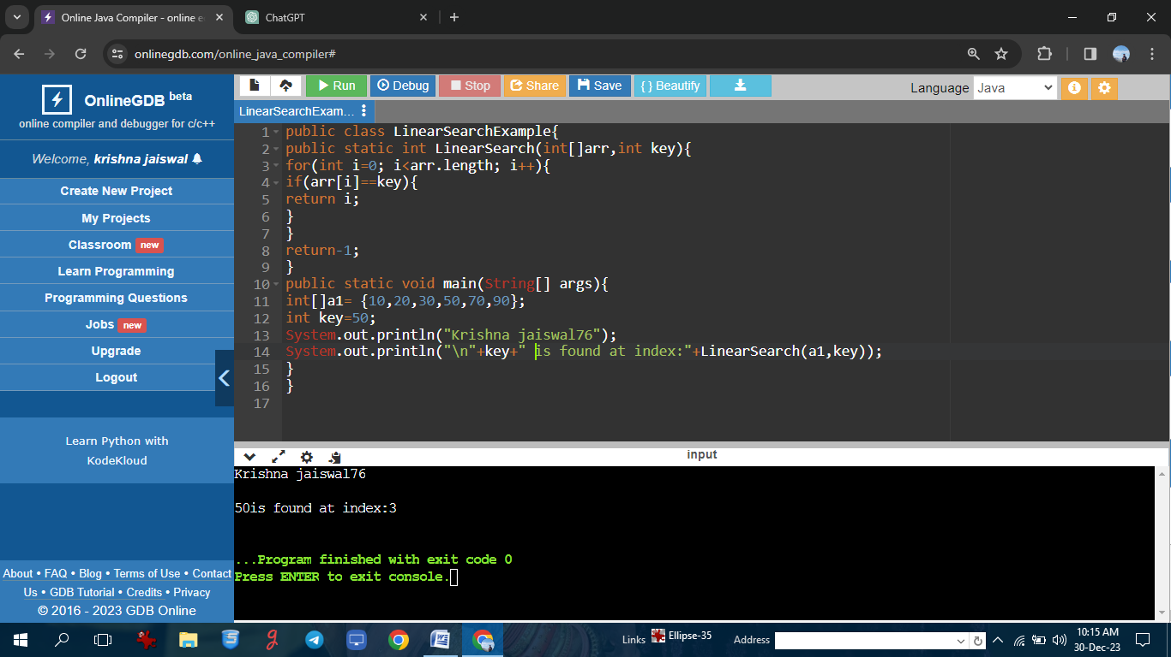

**Private access modifier the program in Java**

**Program: //Krishna jaiswal76**

public class MyClass {

private int privateVariable;

public MyClass(int value) {

this.privateVariable = value;

}

private void privateMethod() {

System.out.println("Inside privateMethod");

System.out.println("privateVariable: " + privateVariable);

}

public void publicMethod() {

System.out.println("Krishna jaiswal76");

System.out.println("Inside publicMethod");

privateMethod();

}

public static void main(String[] args) {

MyClass myObject = new MyClass(42);

myObject.publicMethod();

}}

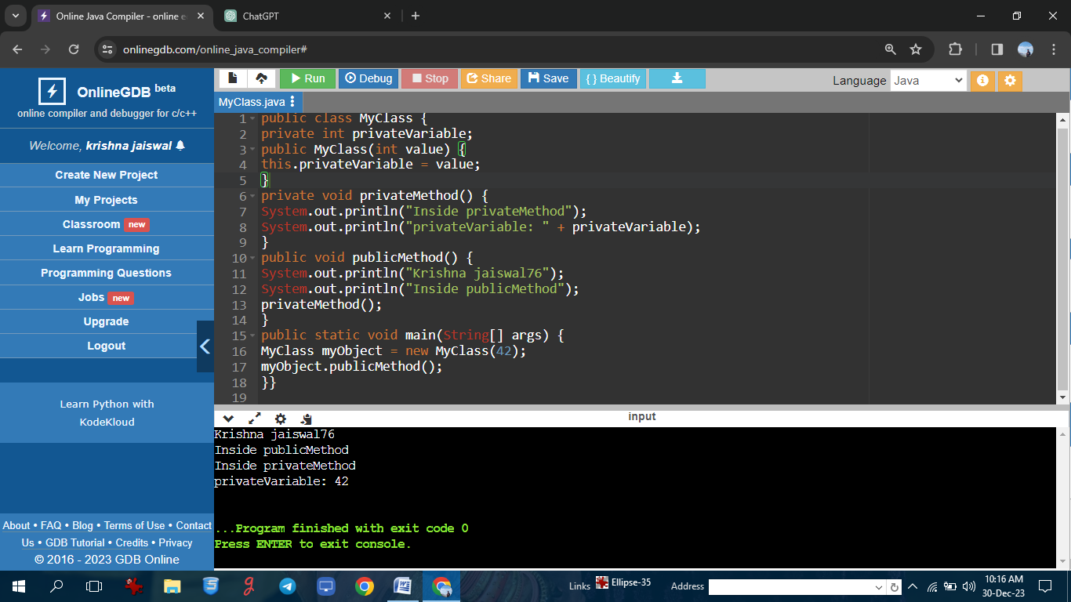

**Protected access modifier program in Java**

**Program: //Krishna jaiswal76**

**// Parent class**

class MyBaseClass {

protected int protectedVariable;

protected void protectedMethod() {

System.out.println("Inside protectedMethod");

System.out.println("protectedVariable: " + protectedVariable);

}

public MyBaseClass(int value) {

this.protectedVariable = value;

}

}

public class MyDerivedClass extends MyBaseClass {

public MyDerivedClass(int value) {

super(value);

}

public void publicMethod() {

System.out.println("Krishna jaiswal76");

System.out.println("Inside publicMethod of MyDerivedClass");

protectedMethod();

}

public static void main(String[] args) {

MyDerivedClass myObject = new MyDerivedClass(42);

myObject.publicMethod();

System.out.println("protectedVariable accessed from MyDerivedClass: " +

myObject.protectedVariable);

}

}

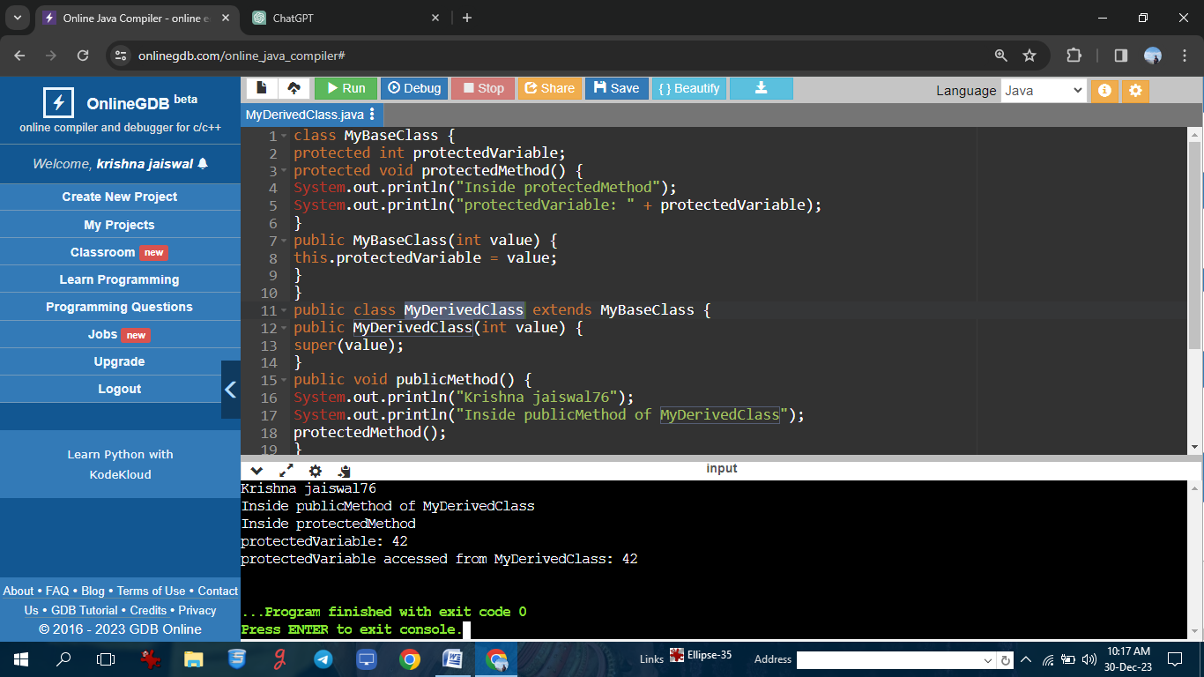

**program to count the number of objects created using constructor**

**Program: //Krishna jaiswal76**

public class Swap{

static int count;

Swap(){

count++;

}

public static void main(String[] args){

Swap s1 = new Swap();

Swap s2 = new Swap();

Swap s3 = new Swap();

System.out.println("Krishna jaiswal76");

System.out.println(count);

}

}

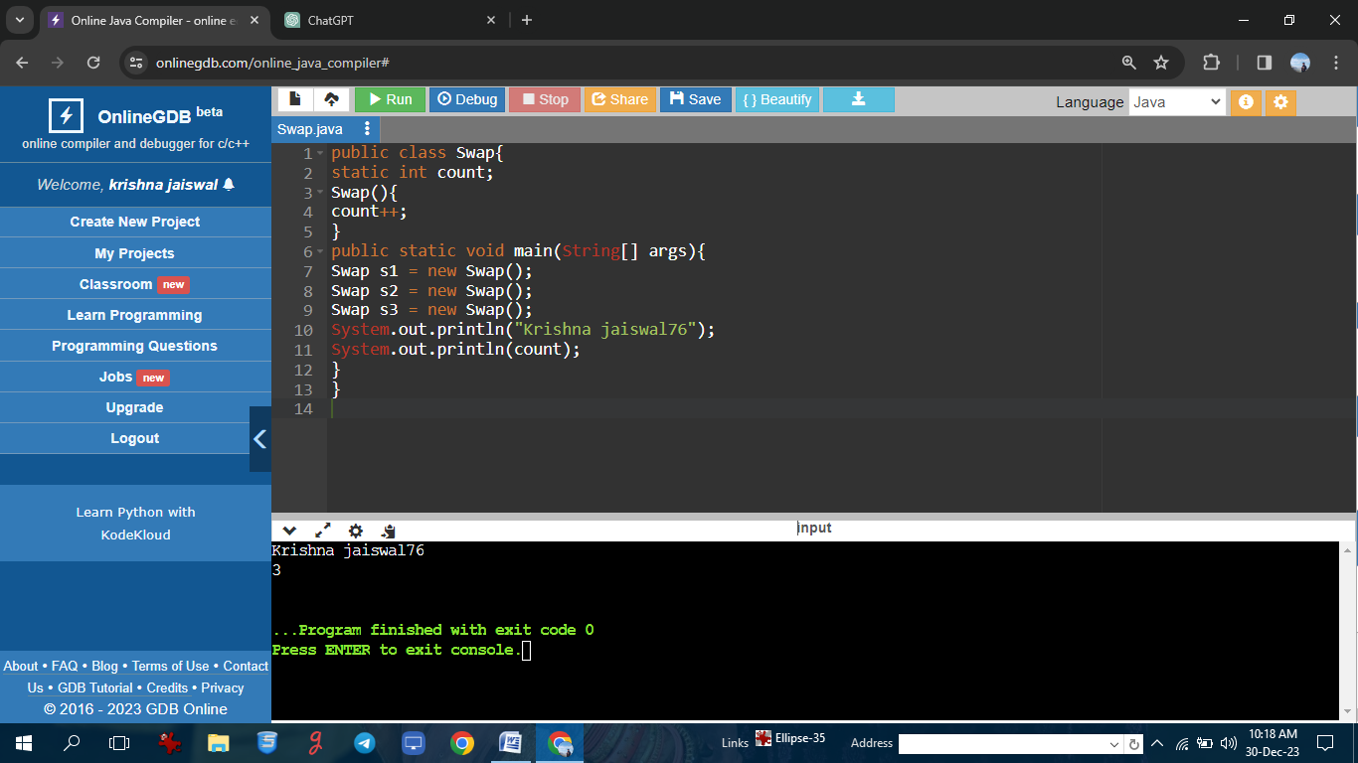

**: program of constructor in Java**

**Program: //Krishna jaiswal76**

public class ConstructorExample {

private int value;

public ConstructorExample() {

System.out.println("Krishna jaiswal76");

System.out.println("Default constructor called");

value = 0;

}

public ConstructorExample(int initValue) {

System.out.println("Parameterized constructor called");

value = initValue;

}

public void displayValue() {

System.out.println("Value: " + value);

}

public static void main(String[] args) {

ConstructorExample obj1 = new ConstructorExample();

obj1.displayValue();

}

}

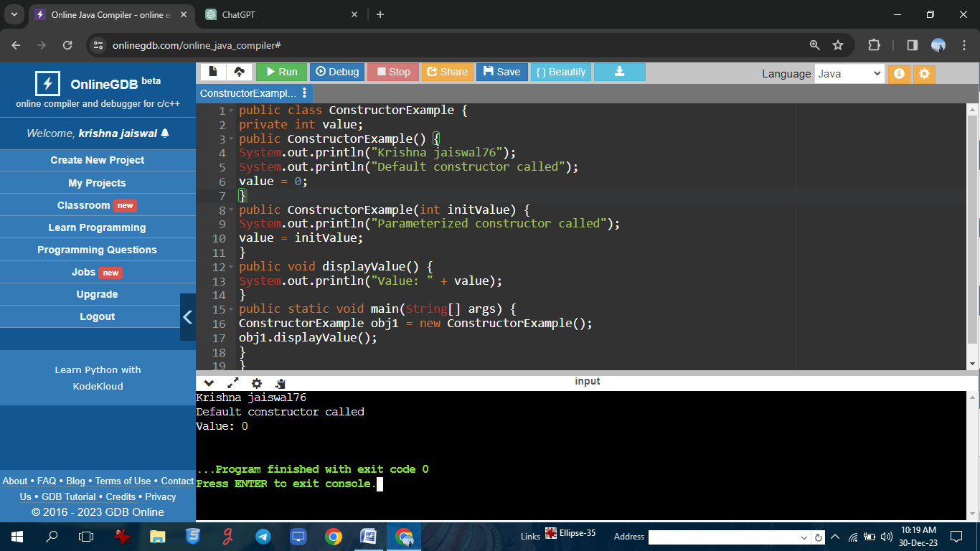

**: To create single inheritance program**

**Program: //Krishna jaiswal76**

**// Superclass**

class Animal {

void eat() {

System.out.println("Krishna jaiswal76");

System.out.println("Animal is eating");

}

}

class Dog extends Animal {

void bark() {

System.out.println("Dog is barking");

}

}

public class SingleInheritanceExample {

public static void main(String[] args) {

Dog myDog = new Dog();

myDog.eat();

myDog.bark();

}

}

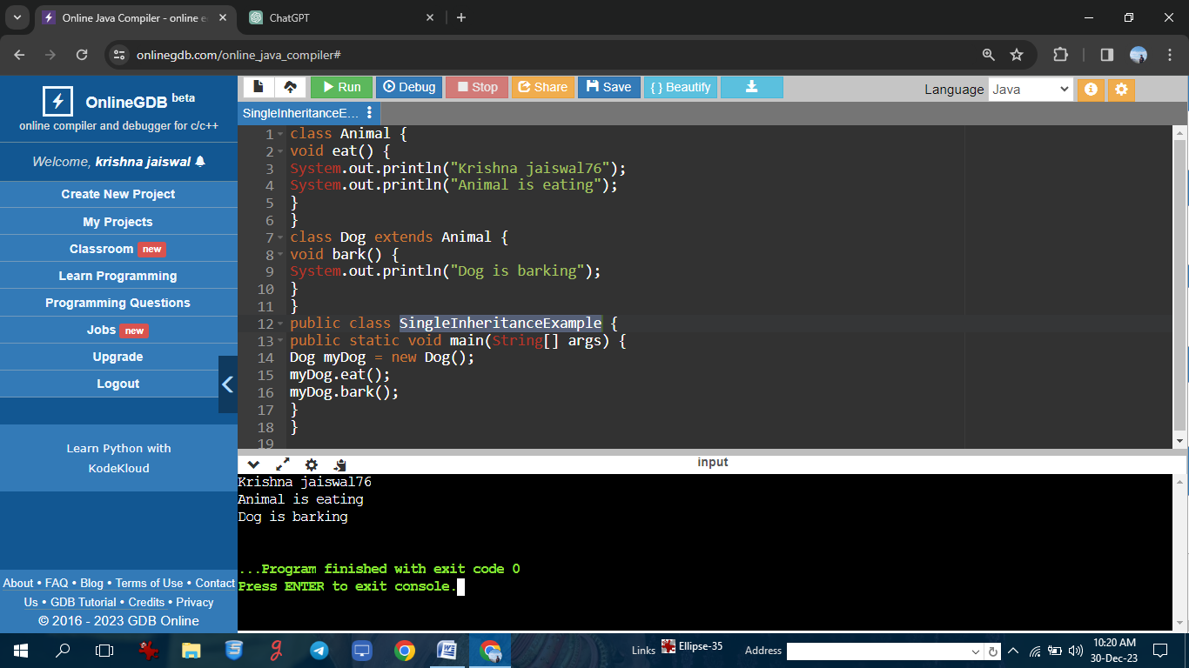

**To create multi-level inheritance program**

**Program: //Krishna jaiswal76**

// Grandparent class

class Animal {

void eat() {

System.out.println("Krishna jaiswal76");

System.out.println("Animal is eating");

}

}

class Dog extends Animal {

void bark() {

System.out.println("Dog is barking");

}

}

class Labrador extends Dog {

void swim() {

System.out.println("Labrador is swimming");

}

}

public class MultilevelInheritanceExample {

public static void main(String[] args) {

Labrador myLabrador = new Labrador();

myLabrador.eat();

myLabrador.bark();

myLabrador.swim();

}

}

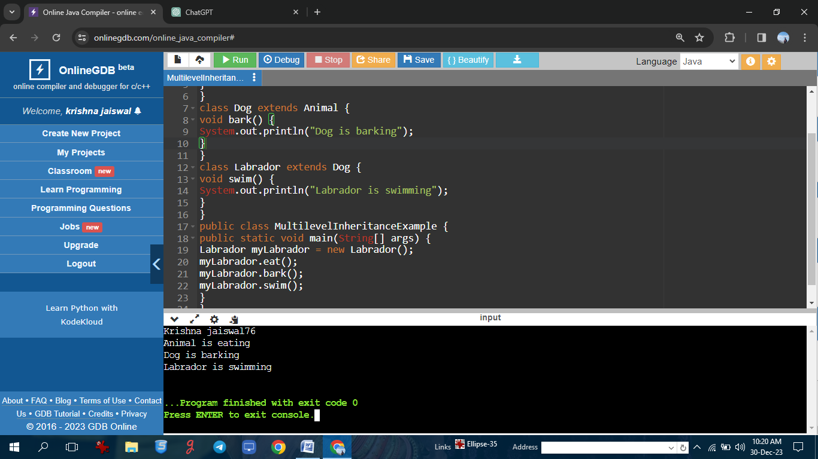

**To demonstrate overloading and overriding**

**Program: //Krishna jaiswal76**

class Parent{

void display(){

System.out.println("this is the parent class");

}

void show(int num){

System.out.println("Krishna jaiswal76");

System.out.println("the sum is the parent class is"+num);

}

}

class Child extends Parent{

void display(){

System.out.println("this is the child class");

}

void show(double num){

System.out.println("this num is the child class is"+num);

}

}

public class Main{

public static void main(String[] args){

Parent parentObj = new Parent();

Child childObj = new Child();

parentObj.show(5);

childObj.show(7.5);

}

}

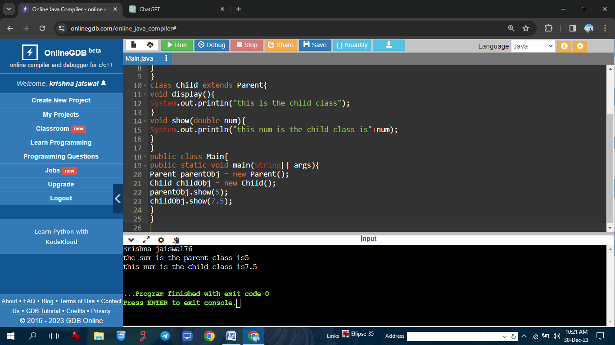

**To demonstrate overloading and overriding**

**Program: //Krishna jaiswal76**

class Animal {

void makeSound() {

System.out.println("Krishna jaiswal76");

System.out.println("Generic animal sound");

}

void eat() {

System.out.println("Animal is eating");

}

}

class Dog extends Animal {

void makeSound(String soundType) {

System.out.println("Dog is making a " + soundType + " sound");

}

@Override

void eat() {

System.out.println("Dog is eating bones");

}

}

public class OverloadingOverridingExample {

public static void main(String[] args) {

Animal genericAnimal = new Animal();

Dog myDog = new Dog();

myDog.makeSound();

myDog.makeSound("bark");

genericAnimal.eat();

myDog.eat();

}

}

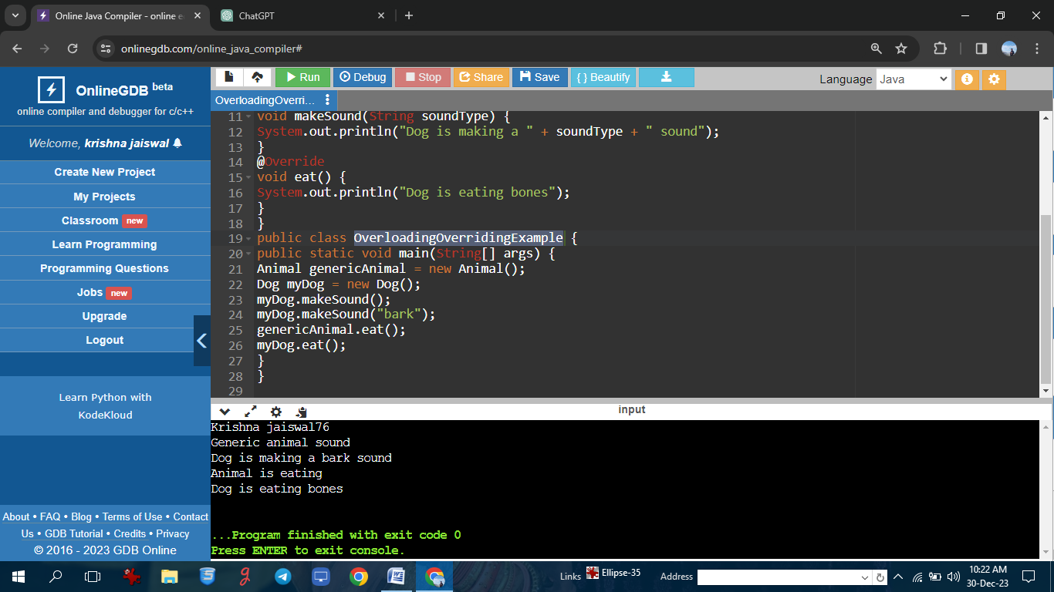

**Program on using a final keyword in Java**

**Program: //Krishna jaiswal76**

class Main{

public static void main(String[] args){

//create a final variable

final int AGE =23;

//try to change the final vaariable

System.out.println("Krishna jaiswal76");

System.out.println("age"+AGE);

}

}

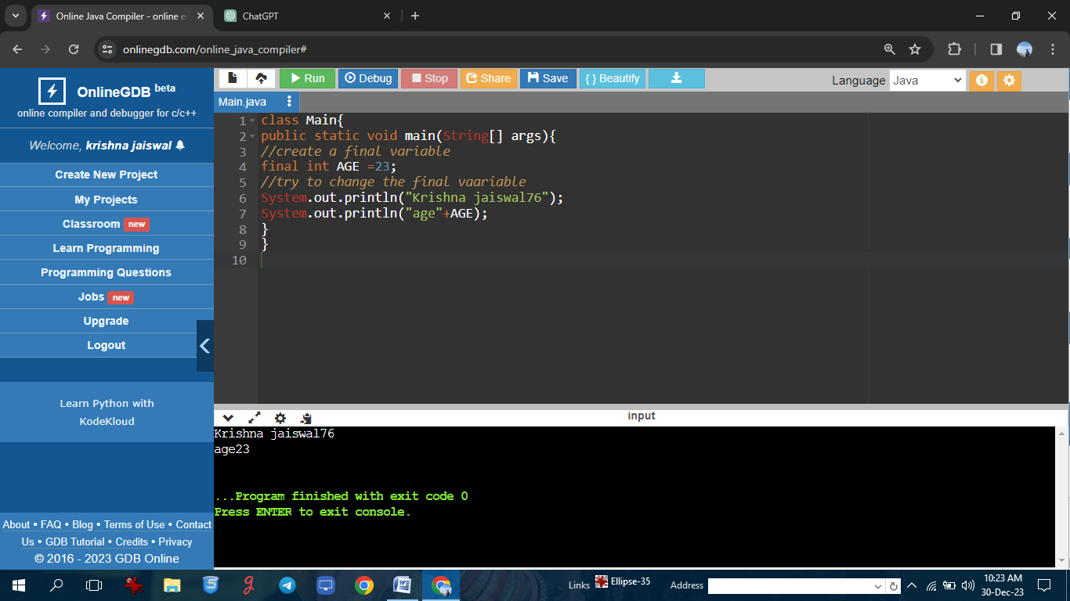

**Program on using a final keyword in Java**

**Program: //Krishna jaiswal76**

// Using final keyword for a class

final class FinalClass {

void display() {

System.out.println("Krishna jaiswal76");

System.out.println("This is a final class");

}

}

class ParentClass {

final void display() {

System.out.println("This is a final method in the parent class");

}

}

class ChildClass extends ParentClass {

}

class Constants {

final int MAX_VALUE = 100;

void displayMaxValue() {

System.out.println("Maximum value is: " + MAX_VALUE);

}

}

public class FinalKeywordExample {

public static void main(String[] args) {

FinalClass finalObj = new FinalClass();

finalObj.display();

Constants constantsObj1 = new Constants();

constantsObj1.displayMaxValue();

}

}

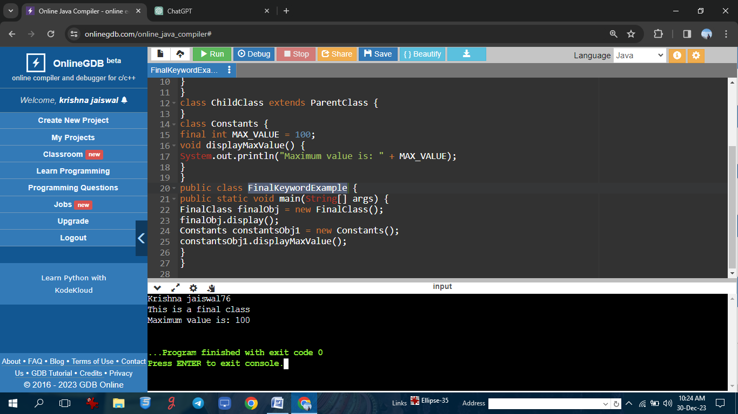

**Program on using this keyword in Java**

**Program: //Krishna jaiswal76**

class Person {

String name;

int age;

Person(String name, int age) {

this.name = name;

this.age = age;

}

void display() {

System.out.println("Krishna jaiswal76");

System.out.println("Name: " + this.name);

System.out.println("Age: " + this.age);

}

void greet() {

System.out.println("Hello, " + this.getName() + "!");

}

String getName() {

return this.name;

}

}

public class ThisKeywordExample {

public static void main(String[] args) {

Person person1 = new Person("keshav", 25);

person1.display();

person1.greet();

}

}

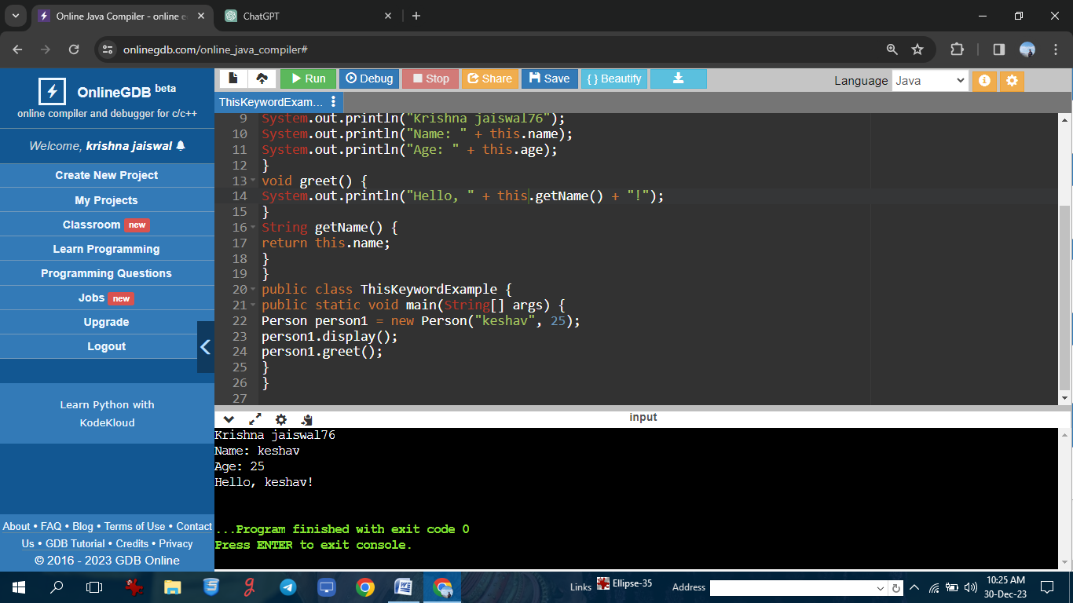

**Program using a this keyword.**

**Program: //Krishna jaiswal76**

public class Box{

private int height;

private int length;

private int breadth;

Box(){

height=0;

length=0;

breadth=0;

}

Box(int height,int length,int breadth){

this.height=height;

this.length=length;

this.breadth=breadth;

}

public int Volume(){

return(length*breadth*height);

}

public static void main(String[] args){

Box cuboid1=new Box();

System.out.println("Krishna jaiswal76");

System.out.println("The area of cuboid is"+cuboid1.Volume());

Box cuboid2=new Box(10,15,30);

System.out.println("The area of cuboid is"+cuboid2.Volume());

}

}

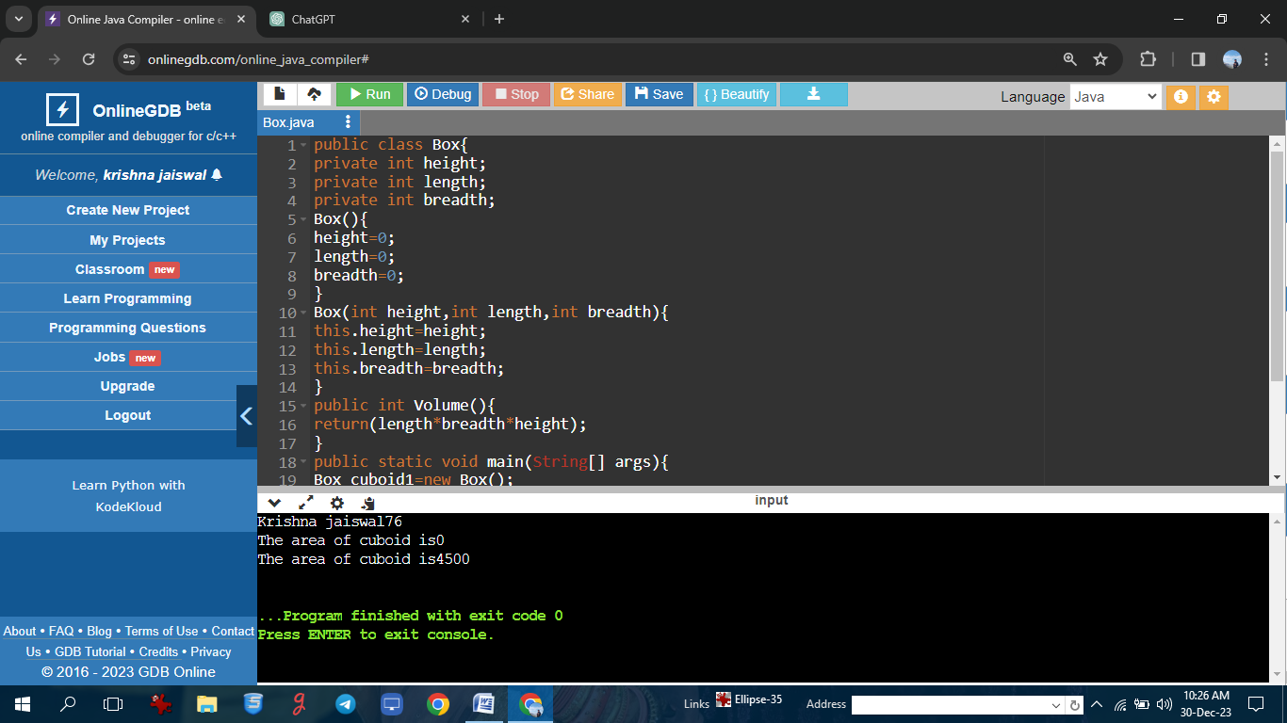

**Program using super keyword**

**Program: //Krishna jaiswal76**

class Animal{

public void eat(){

System.out.println("Krishna jaiswal76");

System.out.println("i can eat");

}}

class Dog extends Animal{

public void eat(){

super.eat();

System.out.println("i eat dog food");

}

public void bark(){

System.out.println("i can bark");

}}

class Main{

public static void main(String[] args){

Dog labrador = new Dog();

labrador.eat();

labrador.bark();

}}

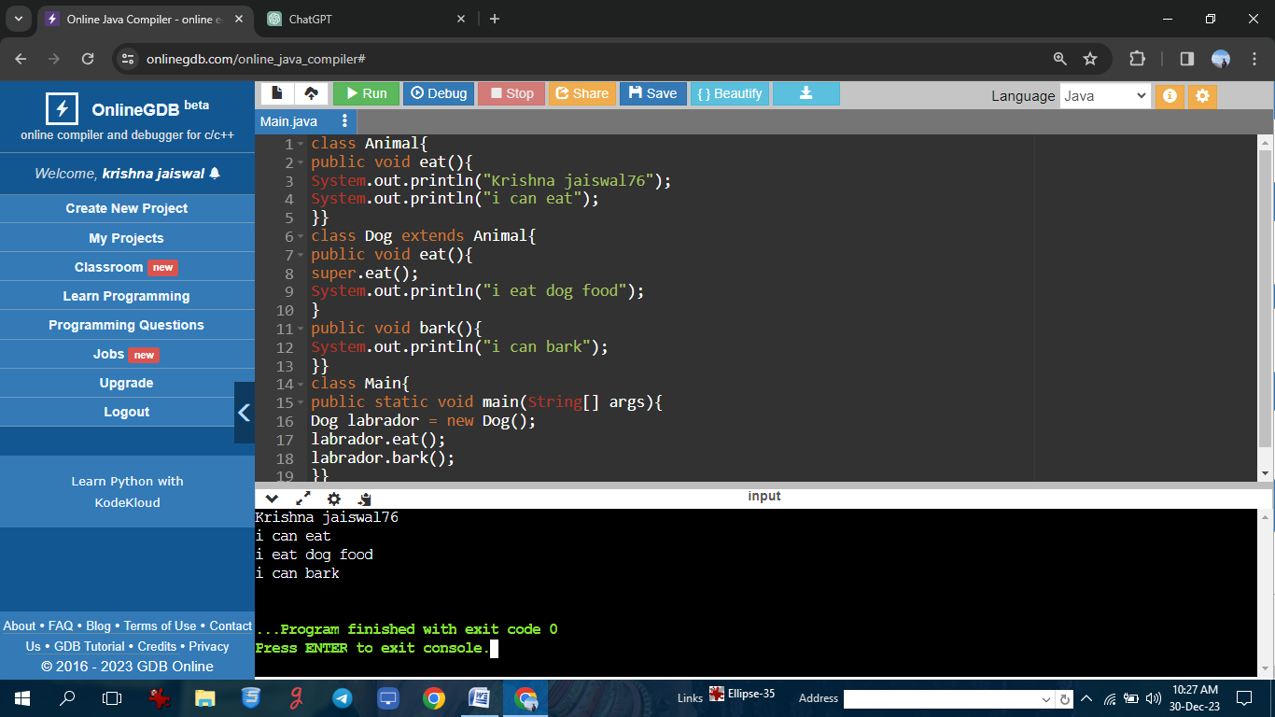

**Program using super keyword**

**Program: //Krishna jaiswal76**

class Animal{

String color="white";

}

class Dog extends Animal{

String color="black";

void printColor(){

System.out.println(color);//prints color of Dog class

System.out.println(super.color);//prints color of Animal class

}

}

class TestSuper1{

public static void main(String args[]){

System.out.println("Krishna jaiswal76");

Dog d=new Dog();

d.printColor();

}

}

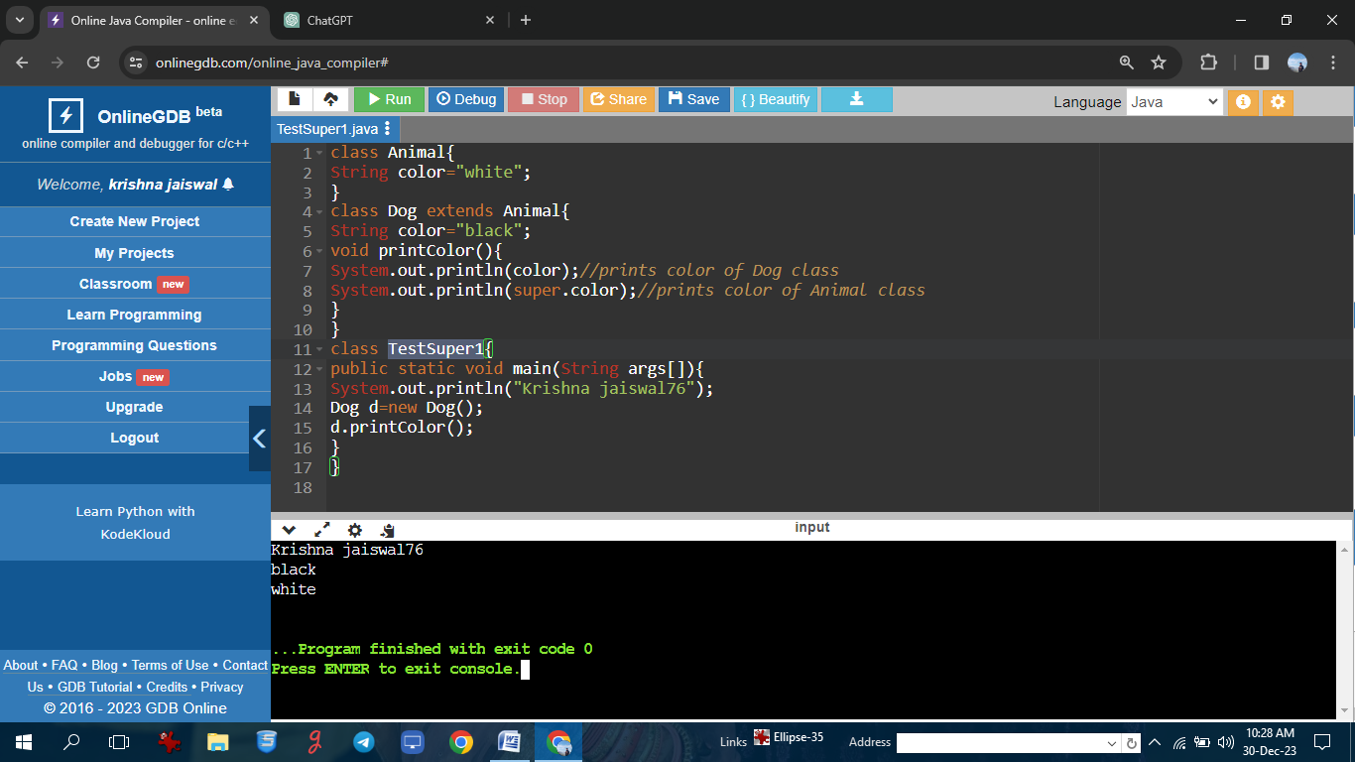

**Program on static member in inheritance**

**Program: //Krishna jaiswal76**

class ParentClass {

static int staticVariable = 10;

int instanceVariable;

static void staticMethod() {

System.out.println("Static method in ParentClass");

}

void instanceMethod() {

System.out.println("Instance method in ParentClass");

}

}

class ChildClass extends ParentClass {

int additionalVariable;

void additionalMethod() {

System.out.println("Additional method in ChildClass");

}

}

public class StaticInheritanceExample {

public static void main(String[] args) {

System.out.println("Krishna jaiswal76");

System.out.println("Static variable from ParentClass: " + ParentClass.staticVariable);

ParentClass.staticMethod();

ChildClass childObj = new ChildClass();

System.out.println("Static variable from ChildClass: " + ChildClass.staticVariable);

ChildClass.staticMethod();

childObj.instanceVariable = 20;

System.out.println("Instance variable from ParentClass via ChildClass object: " +

childObj.instanceVariable);

childObj.instanceMethod();

childObj.additionalVariable = 30;

System.out.println("Additional variable from ChildClass: " +

childObj.additionalVariable);

childObj.additionalMethod();

}

}

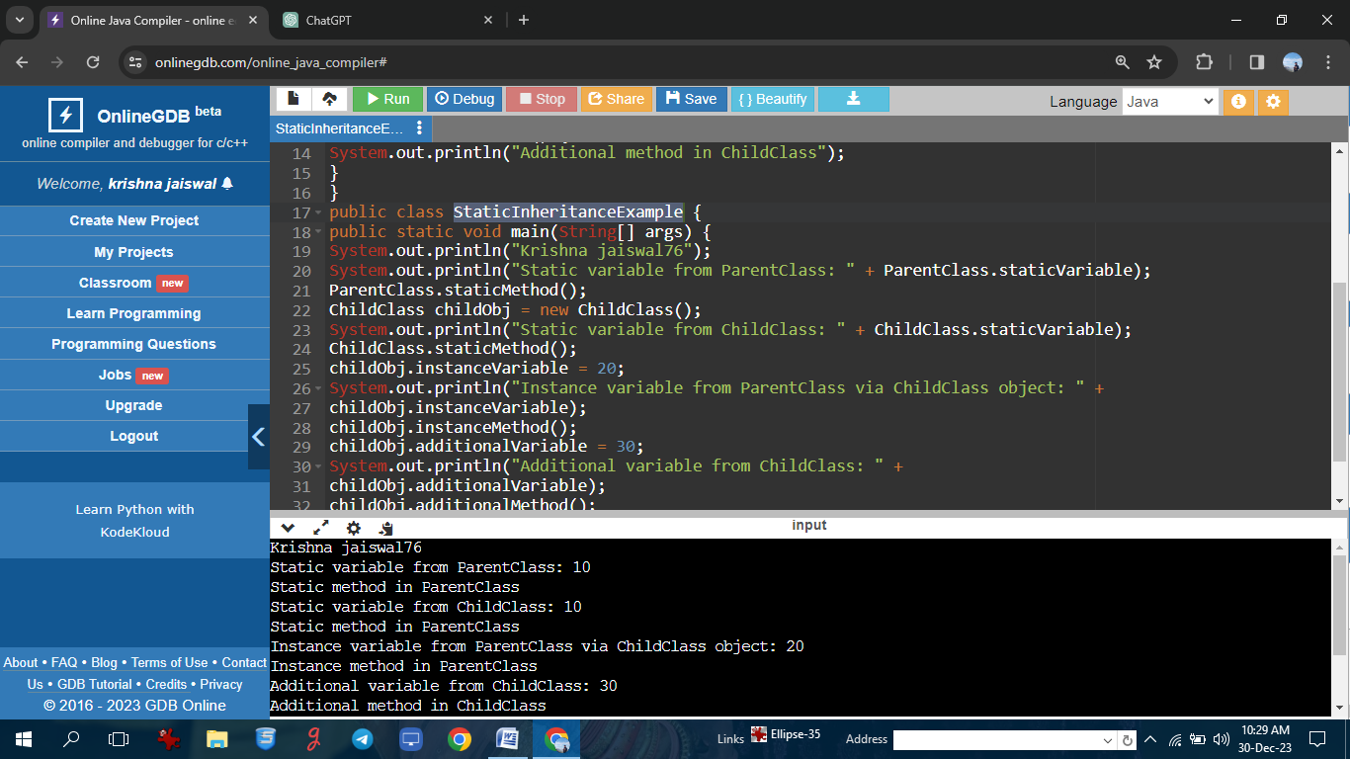

**Program on static member in inheritance**

**Program:**

**//Krishna jaiswal76**

class Parent {

static int staticVarParent = 10;

static void staticMethodParent() {

System.out.println("Static method in Parent class");

}

}

class Child extends Parent {

static int staticVarChild = 20;

static void staticMethodChild() {

System.out.println("Static method in Child class");

}

}

public class StaticInheritanceExample {

public static void main(String[] args) {

System.out.println("Krishna jaiswal76");

System.out.println("Static variable in Parent class: " + Parent.staticVarParent);

Parent.staticMethodParent();

System.out.println("Static variable in Child class: " + Child.staticVarChild);

Child.staticMethodChild();

System.out.println("Static variable in Parent class using Child class reference: " +

Child.staticVarParent);

Child.staticMethodParent();

}

}

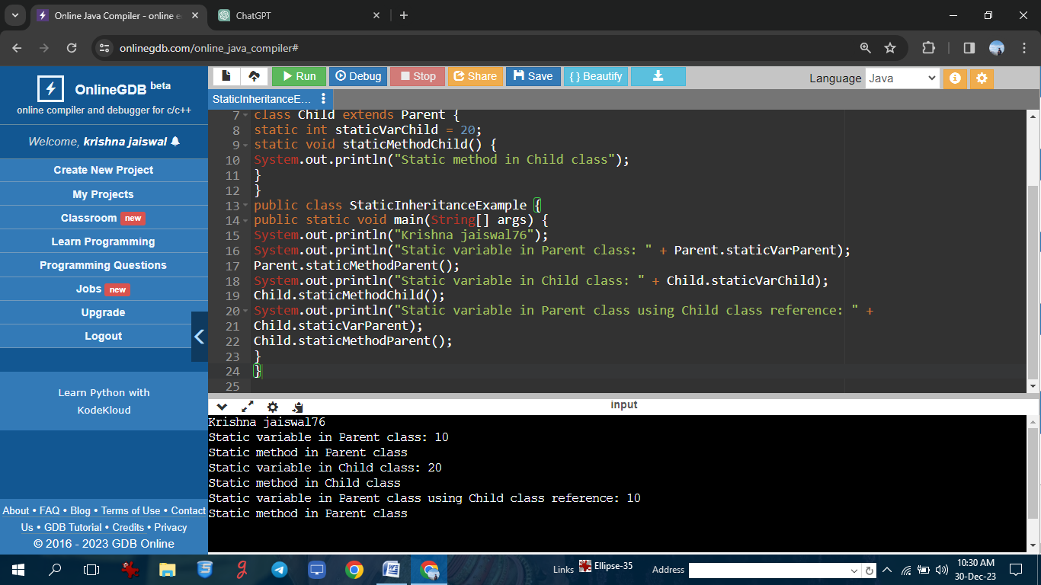

**Program on constructor in inheritance**

**Program: //Krishna jaiswal76**

**// Parent class with a constructor**

class ParentClass {

int parentVariable;

ParentClass(int value) {

System.out.println("Constructor of ParentClass");

this.parentVariable = value;

}

void displayParent() {

System.out.println("Parent Variable: " + parentVariable);

}

}

class ChildClass extends ParentClass {

int childVariable;

ChildClass(int parentValue, int childValue) {

super(parentValue);

System.out.println("Constructor of ChildClass");

this.childVariable = childValue;

}

void displayChild() {

System.out.println("Child Variable: " + childVariable);

}

}

public class ConstructorInheritanceExample {

public static void main(String[] args) {

System.out.println("Krishna jaiswal76");

ChildClass childObj = new ChildClass(10, 20);

childObj.displayParent();

childObj.displayChild();

}

}

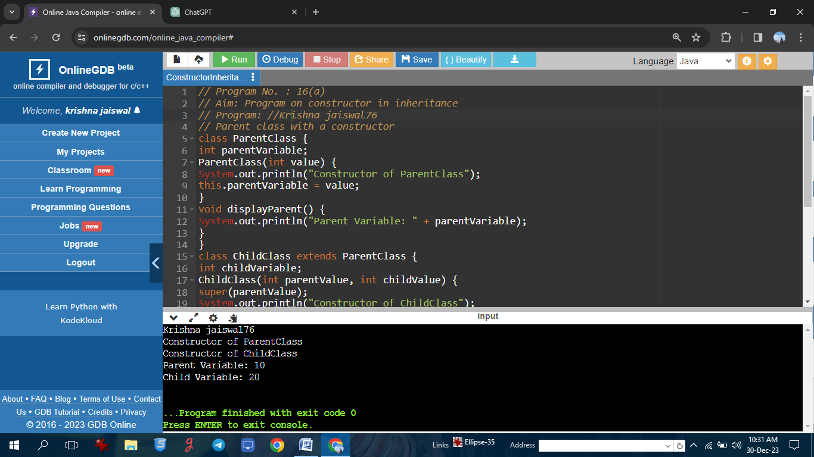

**Program on constructor in inheritance**

**Program: //Krishna jaiswal76**

class Animal {

String name;

Animal(String name) {

this.name = name;

}

}

class Dog extends Animal {

String breed;

Dog(String name, String breed) {

super(name);

this.breed = breed;

}

@Override

public String toString() {

return "Dog{" +

"name='" + name + '\'' +

", breed='" + breed + '\'' +

'}';

}

}

public class Main {

public static void main(String[] args) {

System.out.println("Krishna jaiswal76");

Dog dog = new Dog("Fido", "Golden Retriever");

System.out.println(dog);

}

}

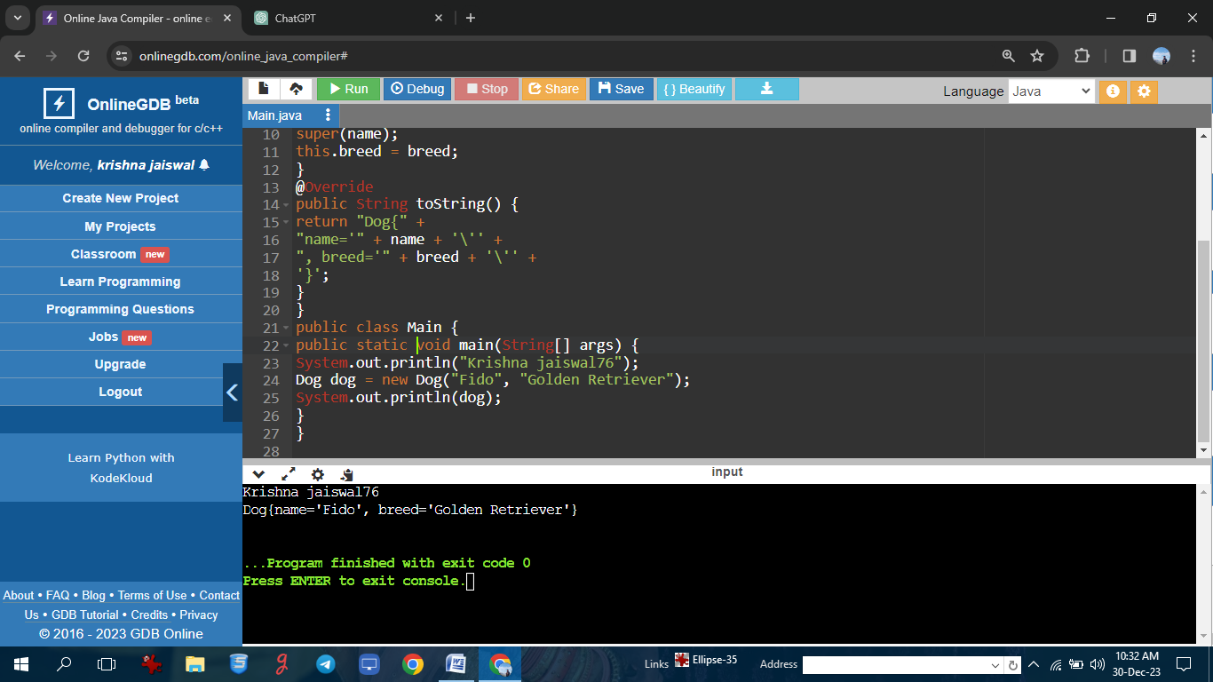

**Program on constructor chaining**

**Program: //Krishna jaiswal76**

class Main{

int sum;

Main(){

//calling the second construction

this(5,2);

}

Main(int arg1,int arg2){

this.sum = arg1 + arg2;

}

void display(){

System.out.println("Krishna jaiswal76");

System.out.println("sum is:"+sum);

}

public static void main(String[] args){

Main obj = new Main();

obj.display();

}

}

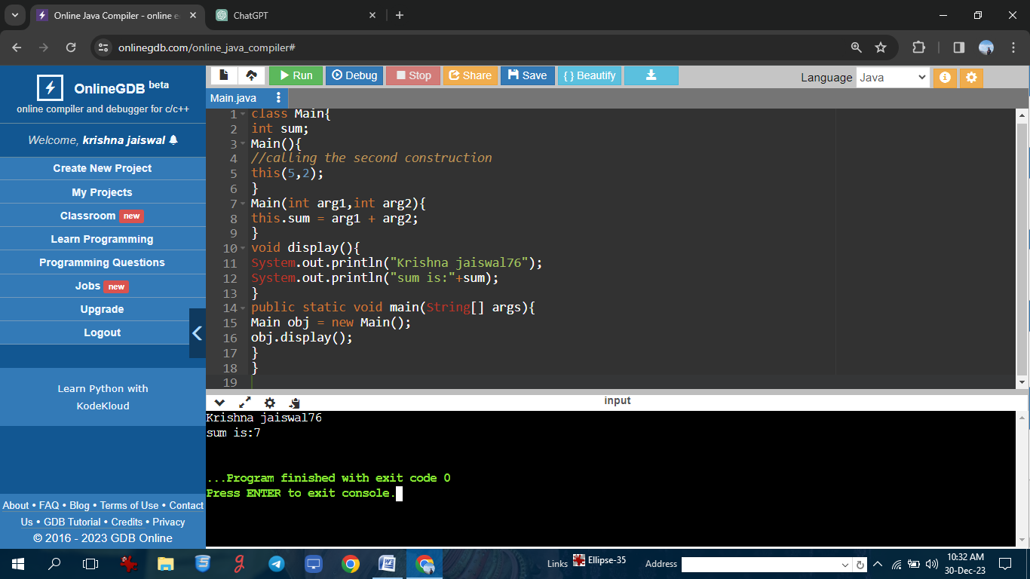

**Program on constructor chaining**

**Program: //Krishna jaiswal76**

class Vehicle {

String type;

Vehicle() {

this("Unknown");

}

Vehicle(String type) {

this.type = type;

System.out.println("Vehicle constructor with type: " + type);

}

}

class Car extends Vehicle {

int numberOfDoors;

Car() {

this(4);

System.out.println("Car default constructor");

}

Car(int numberOfDoors) {

super("Car");

this.numberOfDoors = numberOfDoors;

System.out.println("Car constructor with number of doors: " + numberOfDoors);

}

}

public class ConstructorChainingExample {

public static void main(String[] args) {

System.out.println("Krishna jaiswal76");

Car myCar = new Car();

}

}

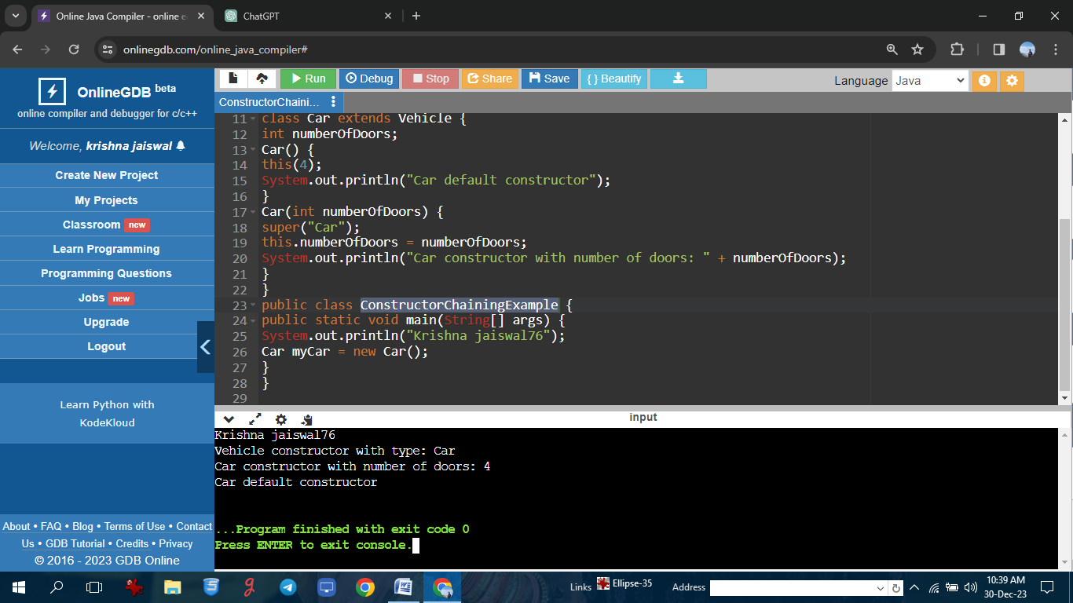

**Programs on Abstract class**

**Program: //Krishna jaiswal76**

// Abstract class with an abstract method

abstract class Shape {

String color;

Shape(String color) {

this.color = color;

}

abstract double calculateArea();

void displayColor() {

System.out.println("Color: " + color);

}}

class Circle extends Shape {

double radius;

Circle(String color, double radius) {

super(color);

this.radius = radius;

}

@Override

double calculateArea() {

return Math.PI * radius * radius;

}}

class Rectangle extends Shape {

double length;

double width;

Rectangle(String color, double length, double width) {

super(color);

this.length = length;

this.width = width;

}

@Override

double calculateArea() {

return length * width;

}}

public class AbstractClassExample {

public static void main(String[] args) {

System.out.println("Krishna jaiswal76");

Circle circle = new Circle("Red", 5.0);

Rectangle rectangle = new Rectangle("Blue", 4.0, 6.0);

circle.displayColor();

System.out.println("Circle Area: " + circle.calculateArea());

rectangle.displayColor();

System.out.println("Rectangle Area: " + rectangle.calculateArea());

}}

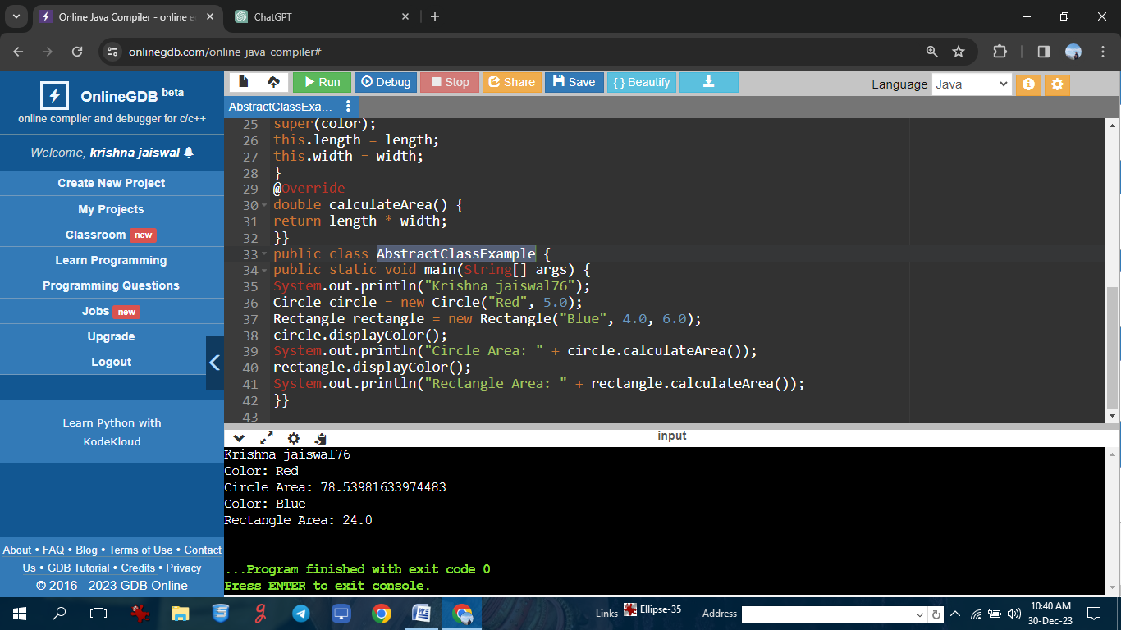

**Programs on Abstract class**

**Program: //Krishna jaiswal76**

abstract class Shape{

abstract void draw();

}

class Rectangle extends Shape{

void draw(){System.out.println("drawing rectangle");}

}

class Circle1 extends Shape{

void draw(){System.out.println("drawing circle");}

}

class TestAbstraction1{

public static void main(String args[]){

System.out.println("Krishna jaiswal76");

Shape s=new Circle1();

s.draw();

}

}

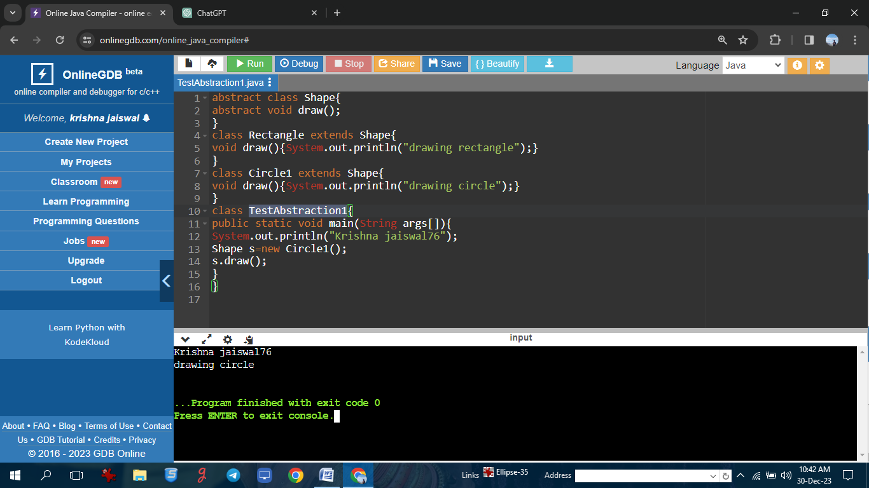

**//Krishna jaiswal76**

interface Calculator{

public void Add(int a,int b);

public void Subtract(double a,double b);

public void Multiply(int i);

}

class A implements Calculator{

public void Add(int a,int b){

System.out.println("Krishna jaiswal76");

java.lang.System.out.println("Add is"+ (a+b));

}

public void Subtract(double a,double b){

java.lang.System.out.println("Subtraction is"+ (a-b)); }

public void Multiply(int i){

java.lang.System.out.println("Multiplication is"+ i*i); }

public static void main(String[] args ){

A a=new A();

a.Add(2,5);

a.Subtract(3.5,2.1);

a.Multiply(4); }}

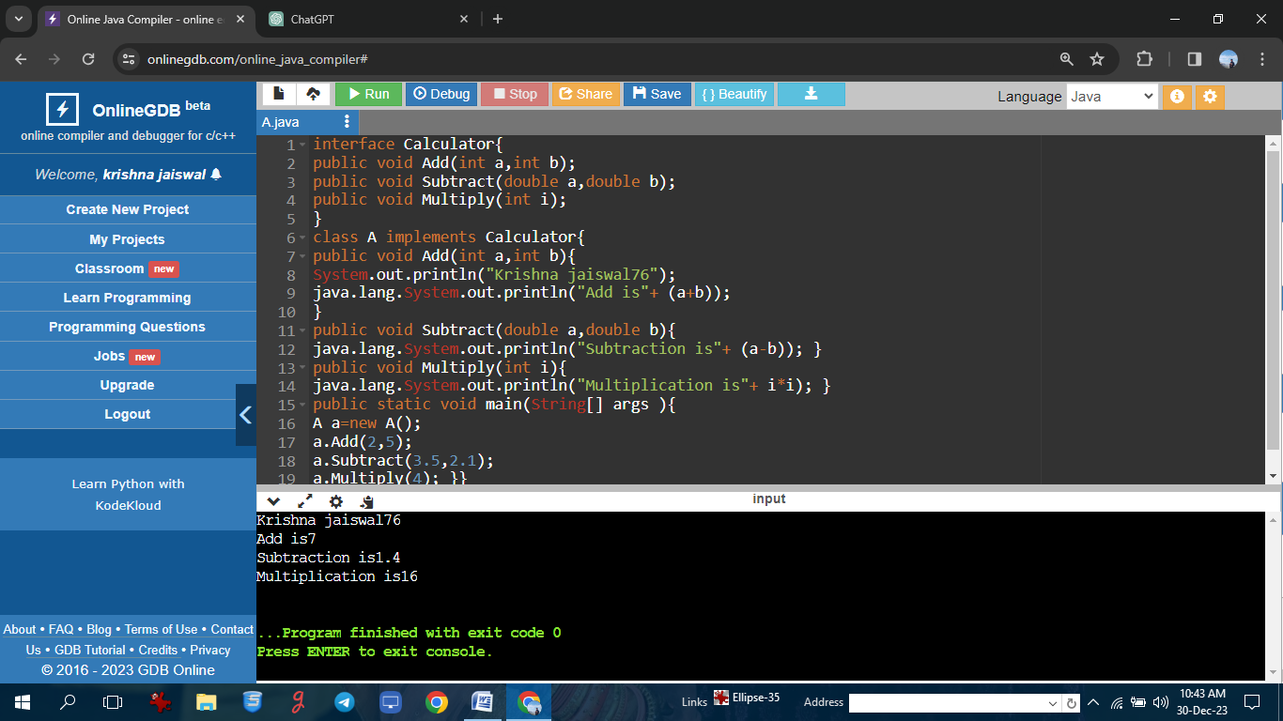

**Program on interface in Java**

**Program: //Krishna jaiswal76**

interface solution{

public void Hello();

public void Welcome();

public void Display(int i);

}

public class A implements solution{

public void Hello(){

System.out.println("Krishna jaiswal76");

java.lang.System.out.println("Hello World");

}

public void Welcome(){

java.lang.System.out.println("Welcome to Edureka"); }

public void Display(int i){

java.lang.System.out.println(i); }

public static void main(String[] args ){

A a=new A();

a.Hello();

a.Welcome();

a.Display(4);

}}

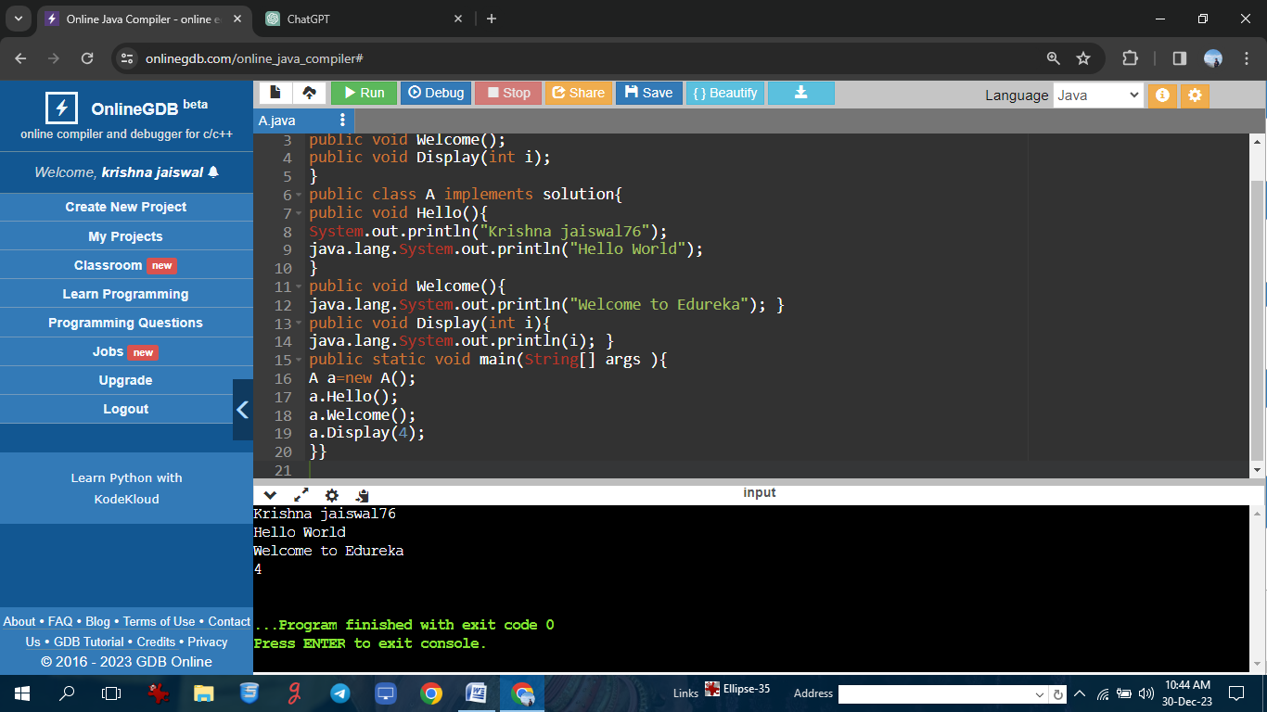

**Program to find min and max of the given integer array in minimum code**

**Program: //Krishna jaiswal76**

import java.util.*;

public class Main{

public static void main(String[] args){

int a[] = {10,30,2,5,6,7};

Arrays.sort(a);

System.out.println("Krishna jaiswal76");

System.out.println("Max"+a[a.length-1]);

System.out.println("Min"+a[0]);

}

}

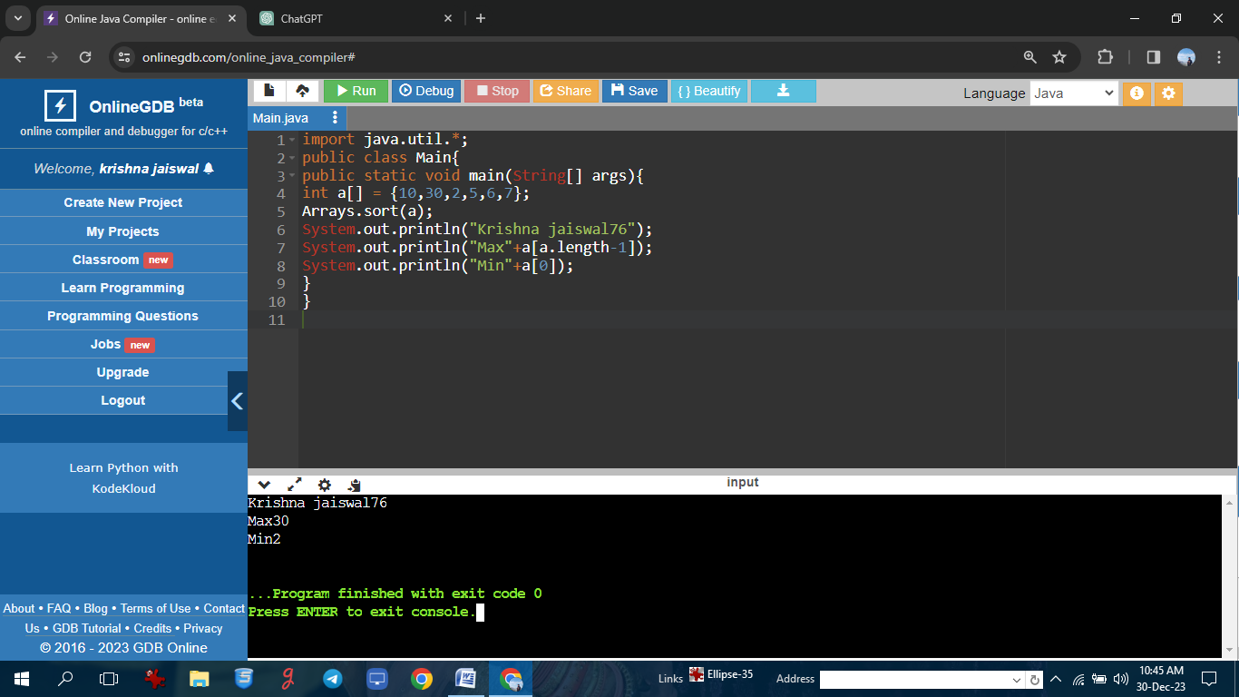

**Program to sort the given integer and string array**

**Program: //Krishna jaiswal76**

import java.util.Arrays;

public class Main{

public static void main(String[] args){

int a[] = {10,30,3,5,4,6};

String s[]={"dog","rat","cat","man"};

System.out.println("Krishna jaiswal76");

System.out.println(Arrays.toString(a));

Arrays.sort(a);

System.out.println(Arrays.toString(a));

System.out.println(Arrays.toString(s));

Arrays.sort(s);

System.out.println(Arrays.toString(s));

}

}

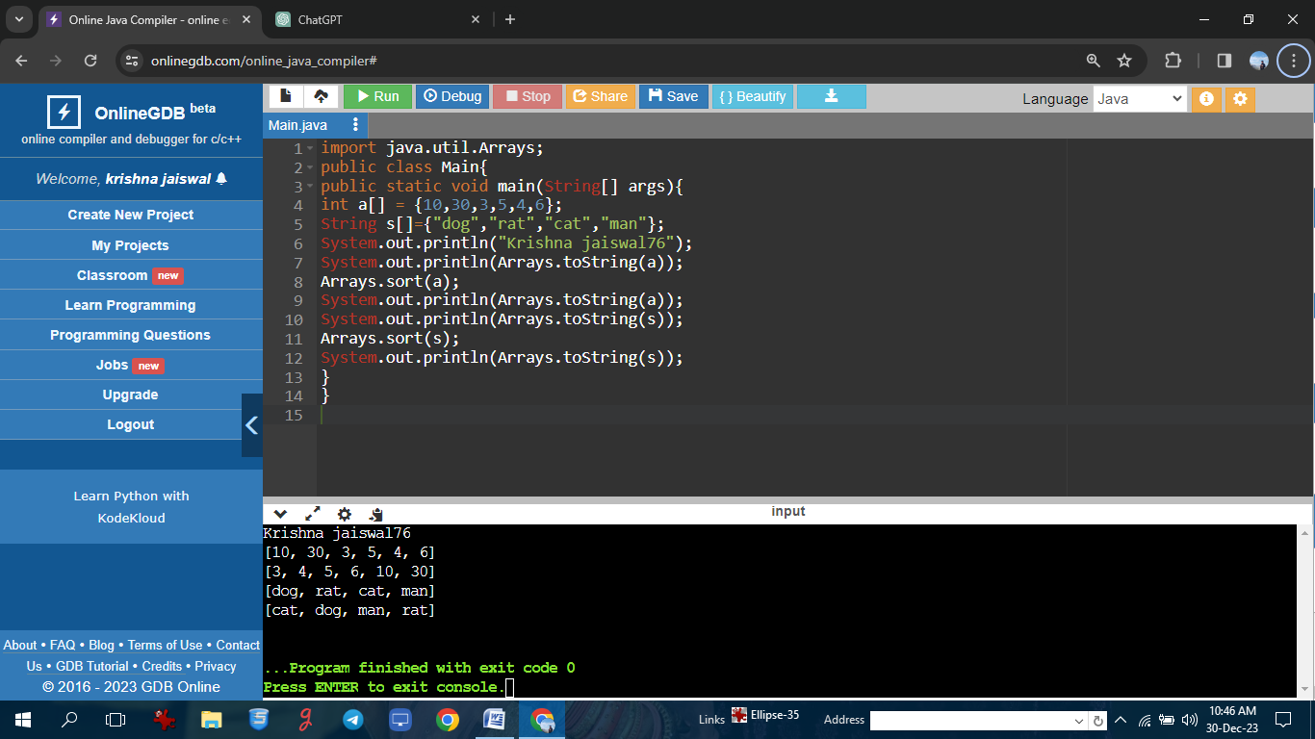

**Program on 2D arrays.**

**Program: //Krishna jaiswal76**

public class TwodimensionalLoop{

public static void main(String[] args)

{

int[][] a={{10,20},{30,40},{50,60}};

System.out.println("Krishna jaiswal76");

System.out.println("Two Dimensional array elements are:");

for(int i=0;i<3;i++)

{

for(int j=0;j<2;j++)

{

System.out.print(a[i][j]+" ");

}

System.out.println(); }

}

}

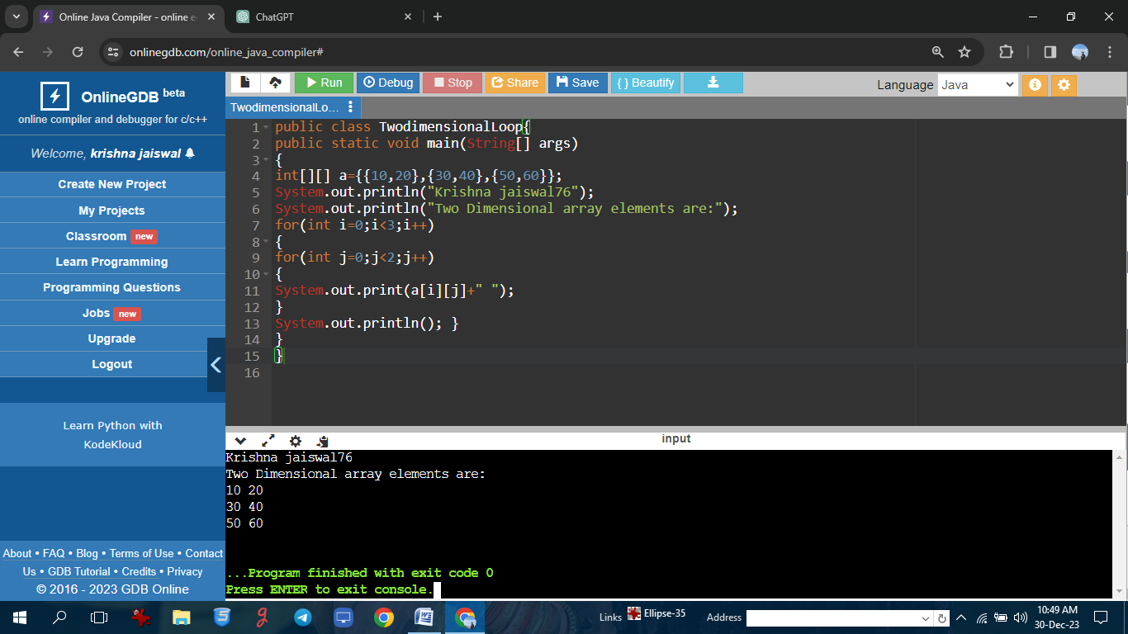

**Program on 2D arrays.**

**Program: //Krishna jaiswal76**

import java.util.Scanner;

public class TwodimensionalLoop{

public static void main(String[] args)

{

Scanner sc=new Scanner(System.in);

int[][] a=new int[4][3];

int i,j;

System.out.println("Krishna jaiswal76");

System.out.println("Enter array elements");

for(i=0;i<4;i++)

{

for( j=0;j<3;j++)

{

a[i][j]=sc.nextInt();

}

System.out.println("Two Dimensional array elements are:");

for( i=0;i<4;i++)

{

for( j=0;j<3;j++)

{

System.out.print(a[i][j]);

}

System.out.println(); }

}

}

}

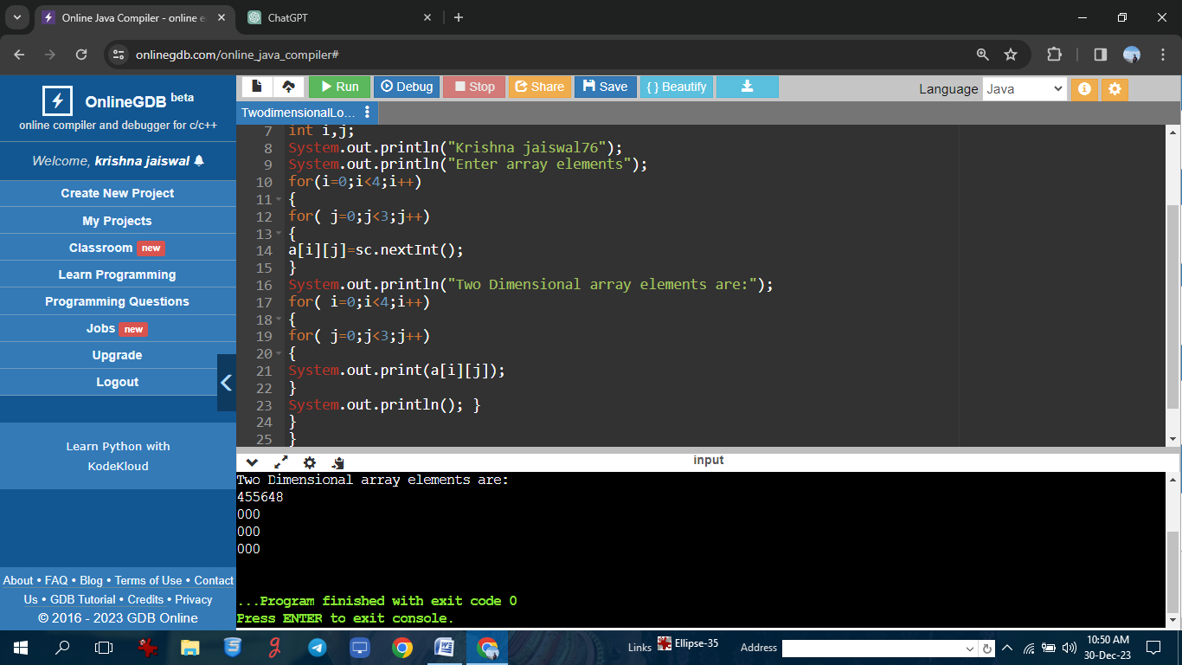

**Program on string class.(compare two string)**

**Program: //Krishna jaiswal76**

class Main{

public static void main(String[] args){

String first = "java programming";

String second = "java programming";

String third = "programming";

boolean result1 = first.equals(second);

System.out.println("Krishna jaiswal76");

System.out.println("string first and second are equal:"+result1);

boolean result2 = first.equals(third);

System.out.println("string first and third are equal:"+result2);

}

}

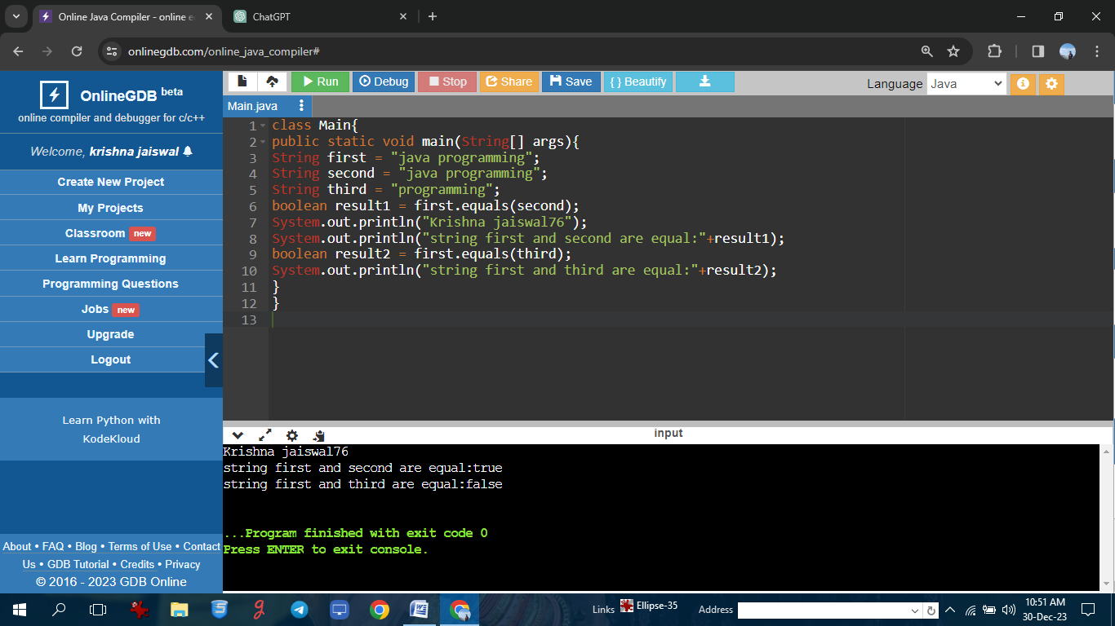

**: Program on string(upper and lower case)**

**Program: //Krishna jaiswal76**

class Main{

public static void main(String[] args){

String s = "Hello World";

System.out.println("Krishna jaiswal76");

System.out.println(s.toUpperCase());

System.out.println(s.toLowerCase());

}

}

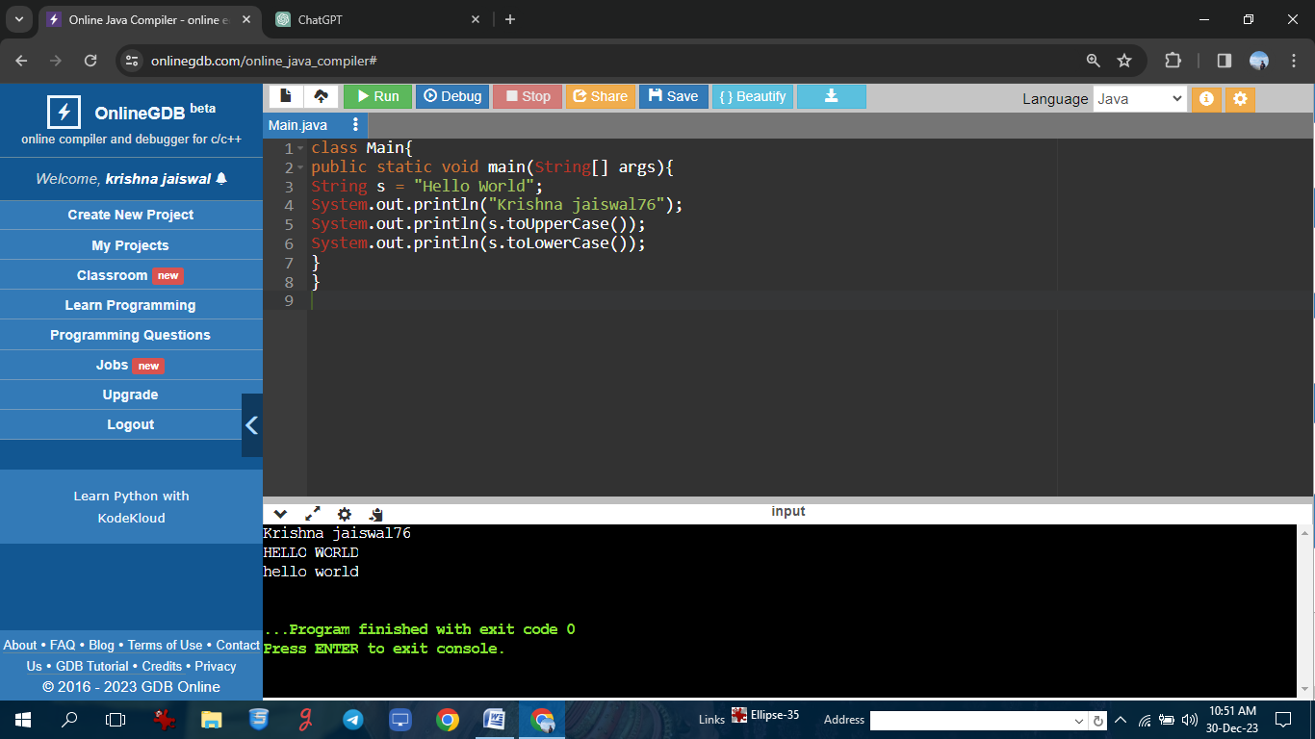

**Program on Exception Handling**

**Program: //Krishna jaiswal76**

class Main{

public static void main(String[] args){

try {

int divideByZero = 5/0;

System.out.println("rest of code");

}

catch(ArithmeticException e){

System.out.println("Krishna jaiswal76");

System.out.println("ArithmeticException =>"+e.getMessage());

}

}

}

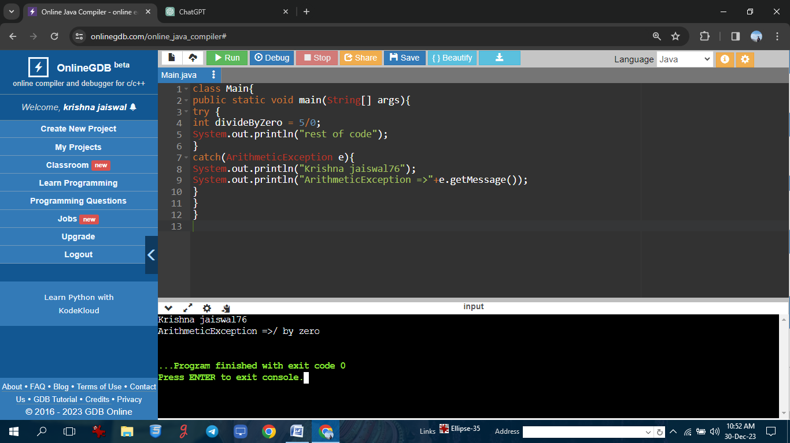

**Program on Exception Handling**

**Program: //Krishna jaiswal76**

import java.util.Scanner;

class Main{

public static void main(String[] args){

try{

int n;

Scanner sc = new Scanner(System.in);

System.out.println("Krishna jaiswal76");

System.out.println("enter value of n:");

n=sc.nextInt();

int divideByzero = 5/n;

System.out.println("rest of code in try block");

}

catch(ArithmeticException e){

System.out.println("ArithmeticException=>"+e.getMessage());

}

}

}

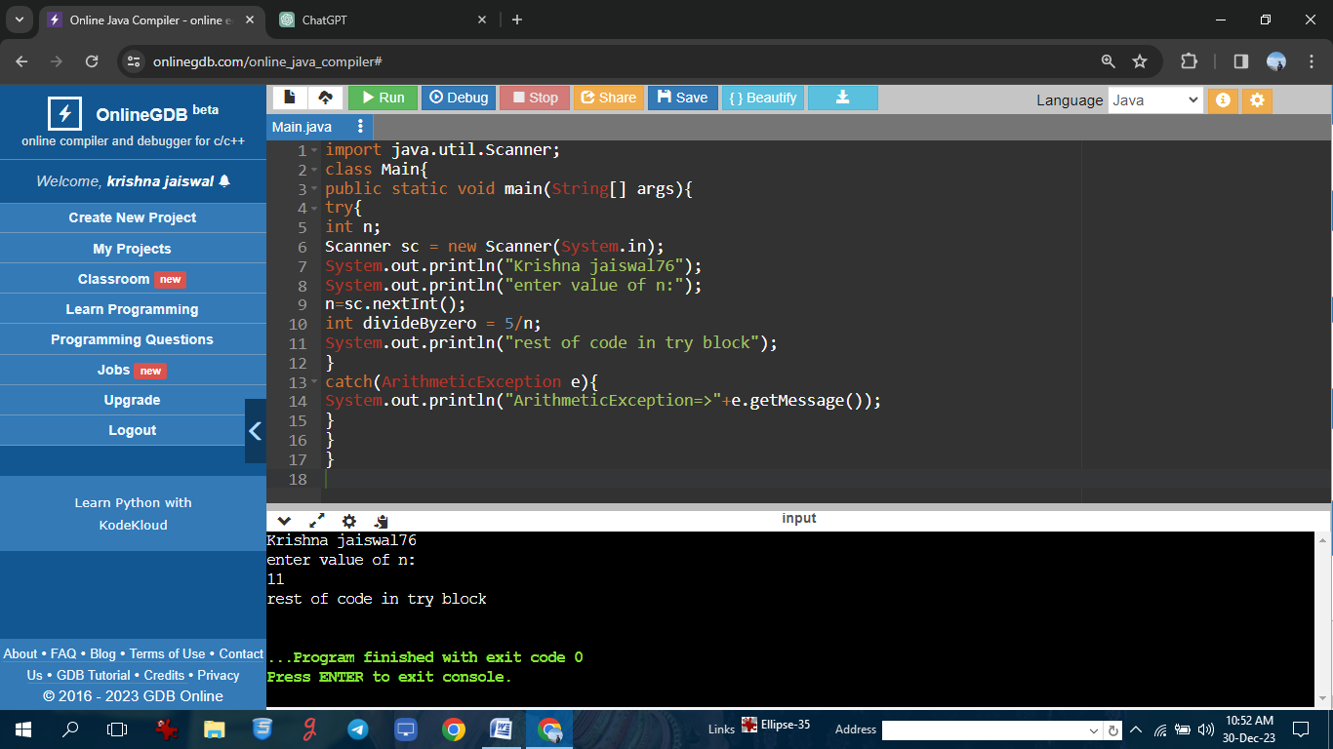

**Program on Unchecked Exception Handling**

**Program: //Krishna jaiswal76**

class MultiCatch{

public static void main(String[] args){

String s = null;

int arr[] = {10,20,30};

try{

System.out.println("Krishna jaiswal76");

System.out.println(s.length());

System.out.println(arr[3]);

}

catch(ArrayIndexOutOfBoundsException e1){

System.out.println("Exception"+e1);

}

catch(NullPointerException e2){

System.out.println("Exception"+e2);

}

}

}

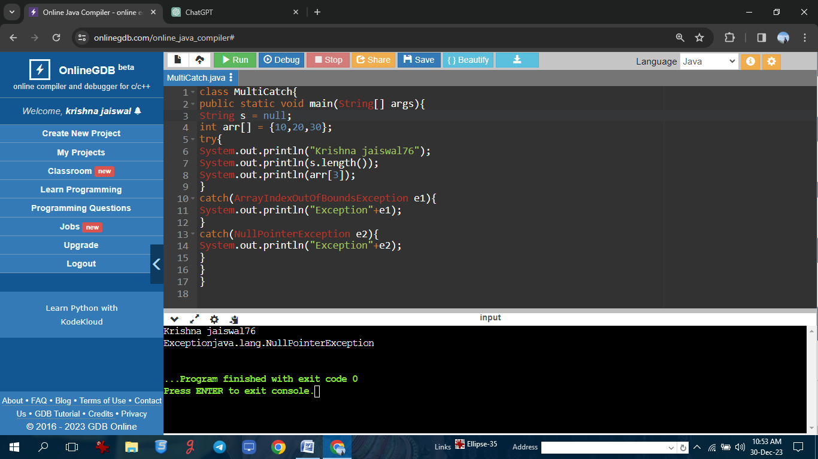

**Program on Unchecked Exception Handling**

**Program: //Krishna jaiswal76**

public class UncheckedExceptionExample1 {

public static void main(String[] args) {

try {

int[] array = new int[5];

// Accessing an index beyond the array length

int value = array[10];

System.out.println("Value: " + value);

} catch (ArrayIndexOutOfBoundsException e) {

System.out.println("Krishna jaiswal76");

System.out.println("Exception caught: " + e);

}

}

}

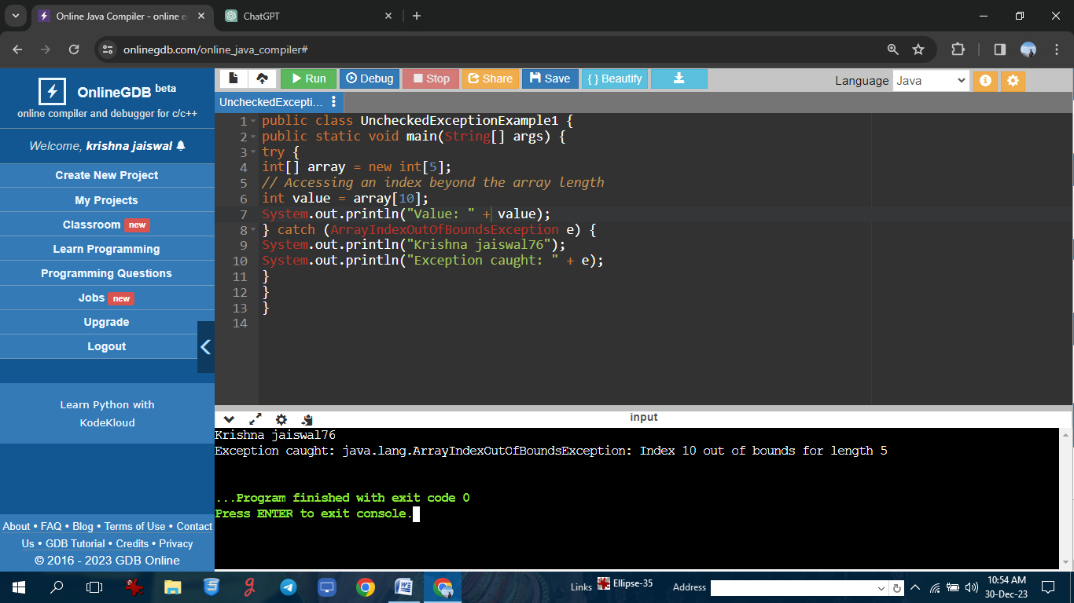

**Program on use of throws in checked exception.**

**Program: //Krishna jaiswal76**

import java.io.FileReader;

import java.io.FileNotFoundException;

public class ThrowsExample1 {

static void readFile(String filePath) throws FileNotFoundException {

FileReader reader = new FileReader(filePath);

}

public static void main(String[] args) {

try {

readFile("nonexistentfile.txt");

} catch (FileNotFoundException e) {

System.out.println("Krishna jaiswal76");

System.out.println("FileNotFoundException caught: " + e.getMessage());

}

}

}

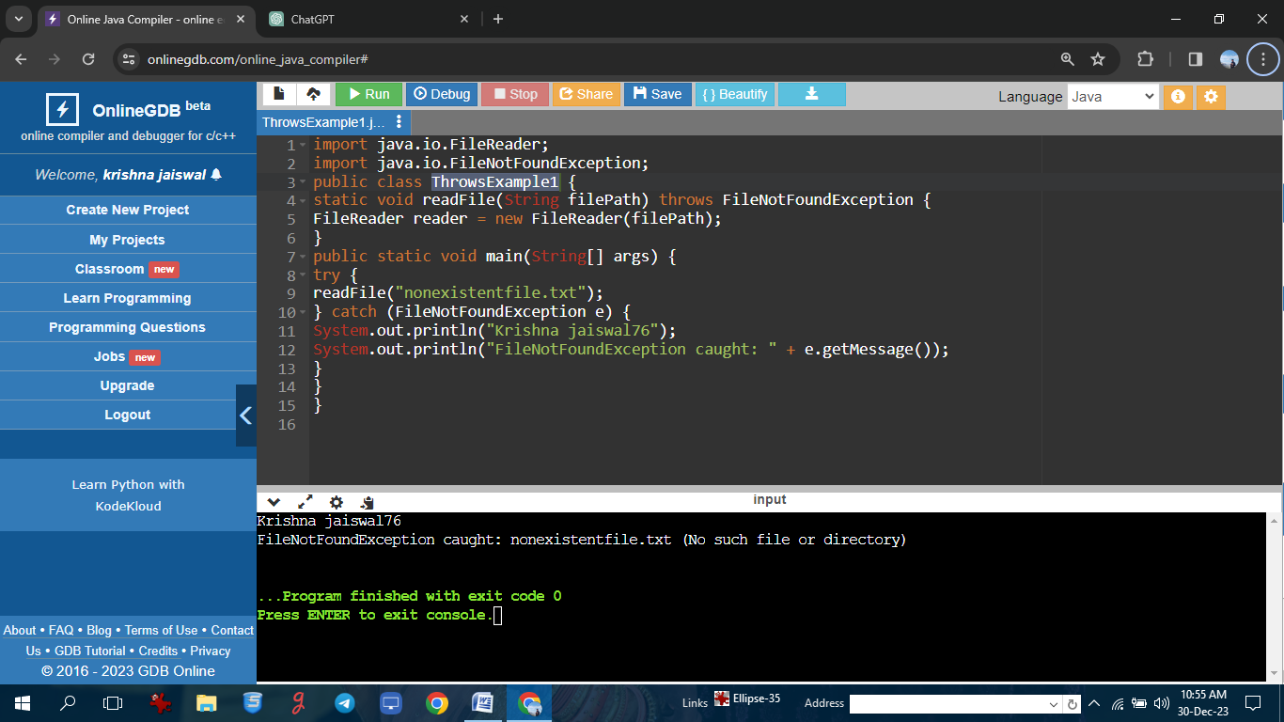

**Program on use of throws in checked exception**

**Program: //Krishna jaiswal76**

import java.io.*;

import java.util.*;

class GFG {

public static void main(String[] args)

throws FileNotFoundException

{

FileInputStream GFG = null;

try {

GFG = new FileInputStream(

"/home/mayur/GFG.txt");

}

catch(FileNotFoundException e){

System.out.println("Krishna jaiswal76");

System.out.println("file does not exists");

}

}

}

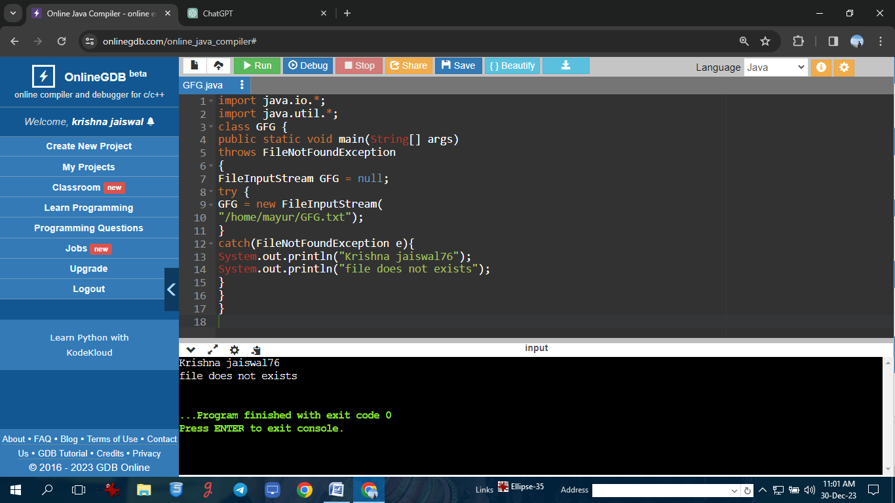

**Program on introduction to threads.**

**Program: //Krishna jaiswal76**

public class Main extends Thread{

public static void main(String[] args){

Main thread = new Main();

thread.start();

System.out.println("Krishna jaiswal76");

System.out.println("this code is outside of the thread");

}

public void run(){

System.out.println("this code is running in a thread");

}

}

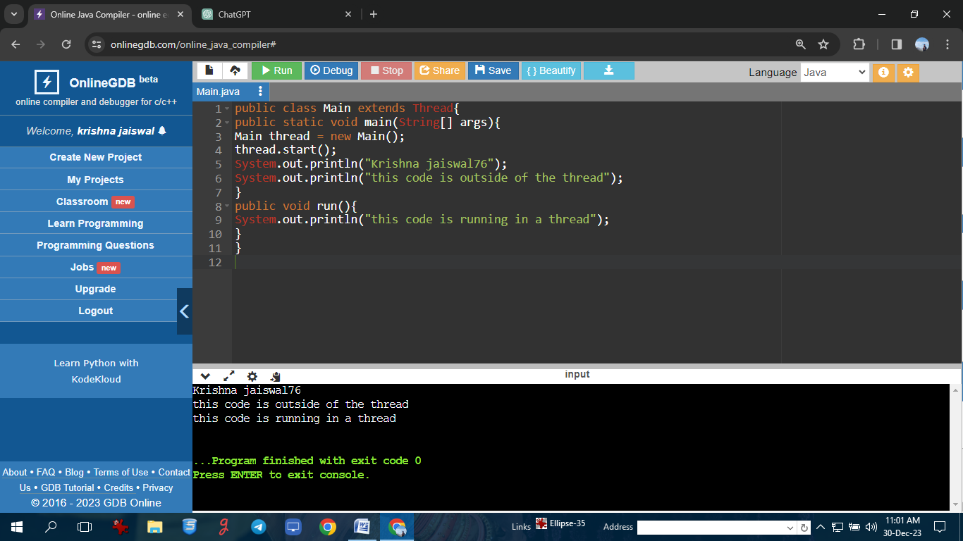

**Program on introduction to threads.**

**Program: //Krishna jaiswal76**

class MyThread extends Thread {

public void run() {

for (int i = 1; i <= 5; i++) {

System.out.println(Thread.currentThread().getId() + " Value " + i);

}

}

}

public class ThreadExample1 {

public static void main(String args[]) {

System.out.println("Krishna jaiswal76");

MyThread thread1 = new MyThread();

MyThread thread2 = new MyThread();

thread1.start();

thread2.start();

}

}

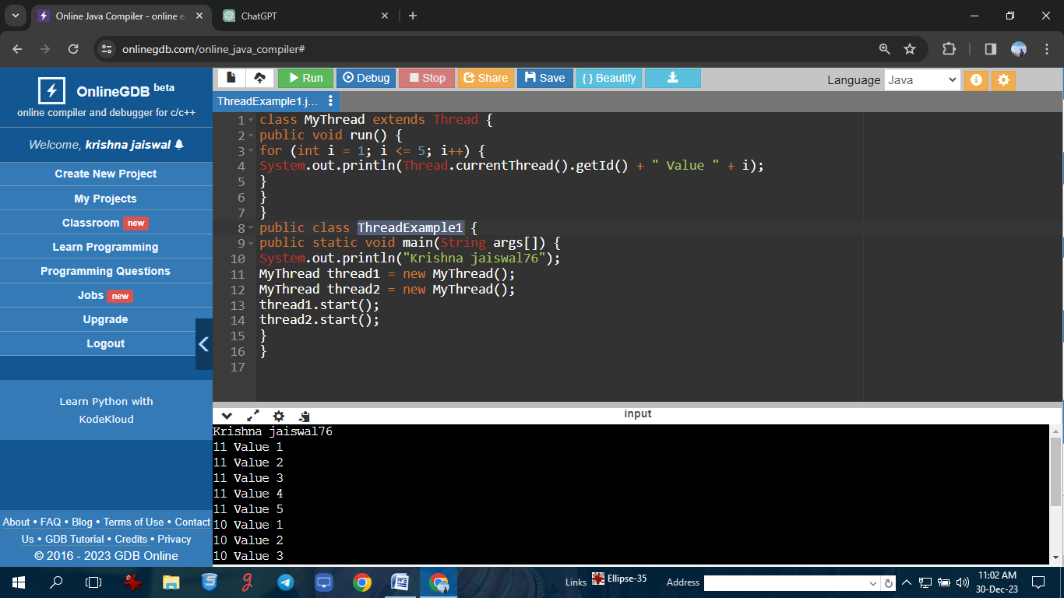

**Program on Threads using Runnable Interface.**

**Program: //Krishna jaiswal76**

public class Main implements Runnable{

public static void main(String[] args){

Main obj = new Main();

Thread thread = new Thread(obj);

thread.start();

System.out.println("Krishna jaiswal76");

System.out.println("this code is outside of the thread");

}

public void run(){

System.out.println("this ccode is running in a thread");

}

}

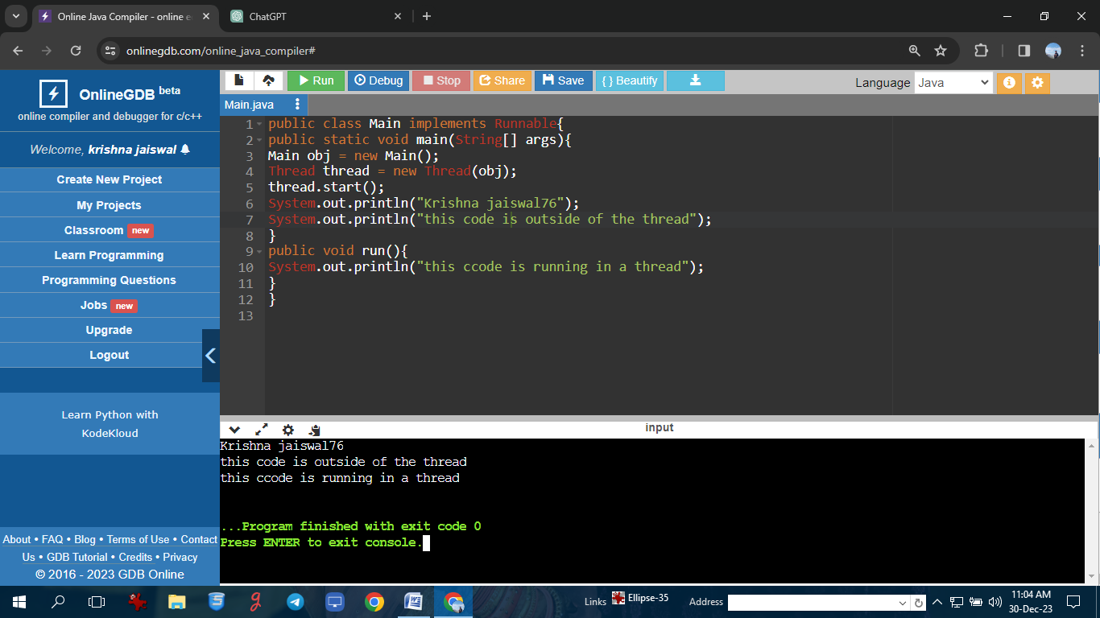

**Program on Threads using Runnable Interface.**

**Program: //Krishna jaiswal76**

public class Thread1 implements Runnable{

public void run(){

try{

Thread.sleep(1500);

System.out.println("Inside of thread");

}

catch(Exception e){

System.out.println("Exception"+e);

}

}

public static void main(String[] args){

for(int i=0;i<5;i++){

Thread t1 = new Thread(new Thread1());

t1.start();

}

System.out.println("Krishna jaiswal76");

System.out.println("outside of thread");

}}

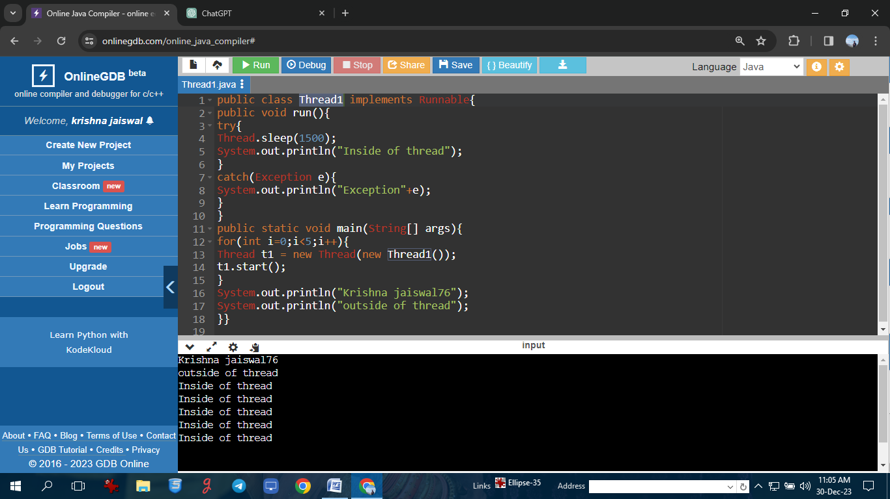

**: Program on Threads using Thread Class.**

**Program: //Krishna jaiswal76**

class MyThread extends Thread {

public void run() {

for (int i = 1; i <= 3; i++) {

System.out.println(Thread.currentThread().getId() + " Value " + i);

}

}

}

public class ThreadUsingThreadClassExample1 {

public static void main(String args[]) {

System.out.println("Krishna jaiswal76");

MyThread thread1 = new MyThread();

MyThread thread2 = new MyThread();

thread1.start();

thread2.start();

}

}

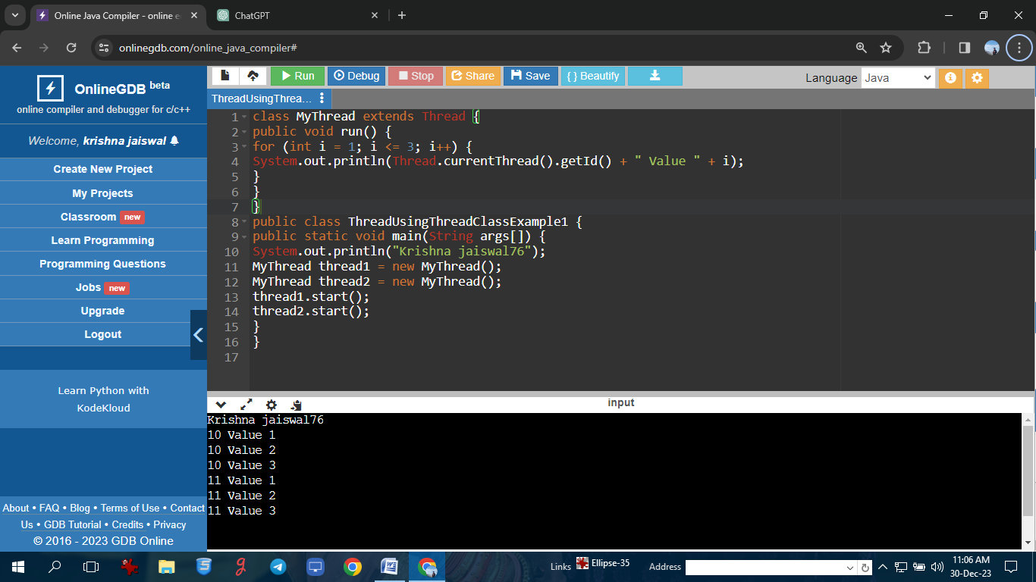

**: Program on Threads using Thread Class.**

**Program: //Krishna jaiswal76**

class SleepThread extends Thread {

public void run() {

for (int i = 1; i <= 2; i++) {

try {

Thread.sleep(1000); // Sleep for 1 second

} catch (InterruptedException e) {

e.printStackTrace();

}

System.out.println(Thread.currentThread().getName() + " Value " + i);

}}}

public class ThreadUsingThreadClassExample3 {

public static void main(String args[]) {

System.out.println("Krishna jaiswal76");

SleepThread thread1 = new SleepThread();

SleepThread thread2 = new SleepThread();

thread1.start();

thread2.start();

}}

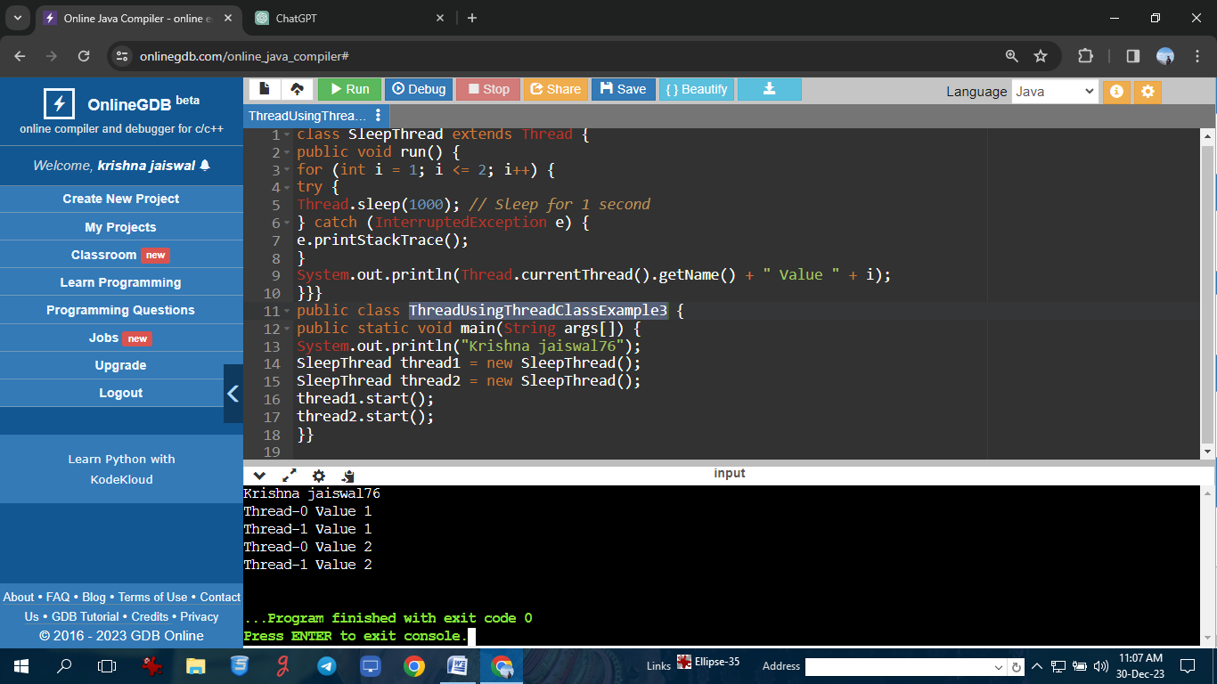

**Program on introduction to file handling.**

**Program: //Krishna jaiswal76**

import java.io.File;

public class CreateFile {

public static void main(String[] args) {

try {

System.out.println("Krishna jaiswal76");

File myFile = new File("myfile.txt");

if (myFile.createNewFile()) {

System.out.println("File created: " + myFile.getName());

} else {

System.out.println("File already exists.");

}

} catch (Exception e) {

System.out.println("An error occurred.");

e.printStackTrace();

}

}

}

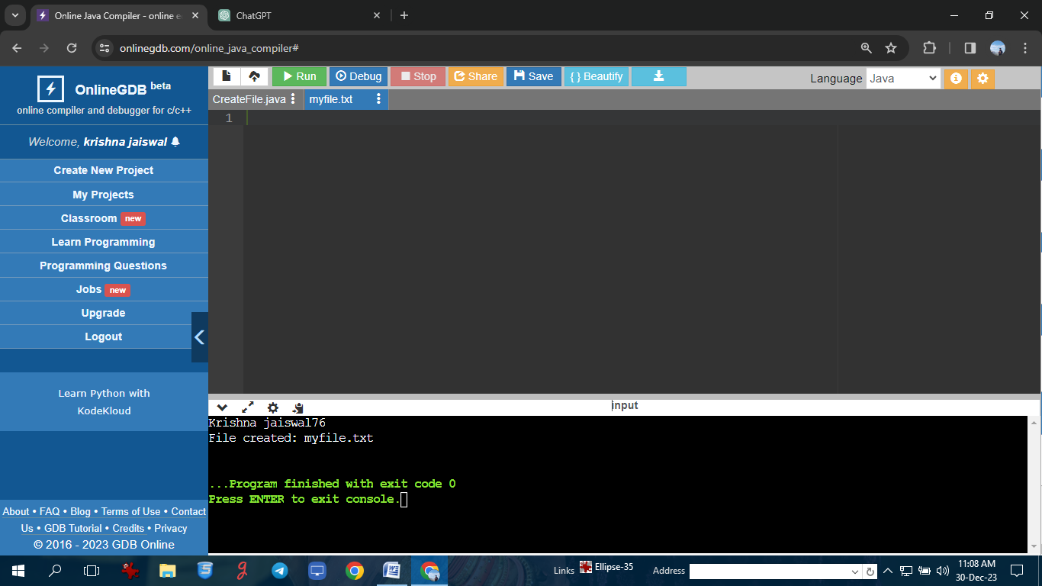

**Program on introduction to file handling.**

**Program: //Krishna jaiswal76**

import java.io.File;

import java.io.FileWriter;

public class WriteToFile {

public static void main(String[] args) {

try {

System.out.println("Krishna jaiswal76");

File myFile = new File("myfile.txt");

FileWriter myWriter = new FileWriter(myFile);

myWriter.write("Hello, World!");

myWriter.close();

System.out.println("Successfully wrote to the file.");

} catch (Exception e) {

System.out.println("An error occurred.");

e.printStackTrace();

}

}

}

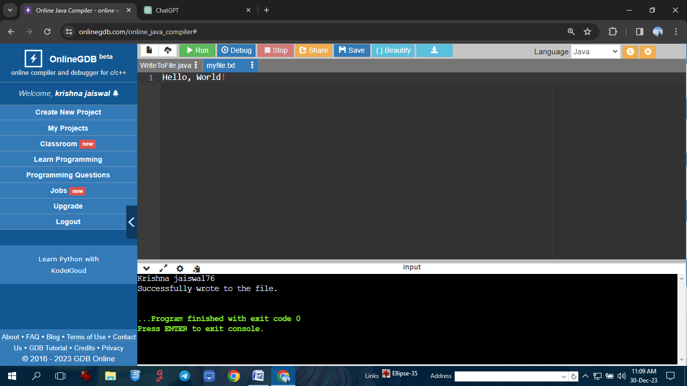

**Program on File class.**

**Program: //Krishna jaiswal76**

import java.io.File;

import java.io.IOException;

public class FileClassExample1 {

public static void main(String[] args) {

System.out.println("Krishna jaiswal76");

String filePath = "newfile.txt";

File file = new File(filePath);

try {

if (file.createNewFile()) {

System.out.println("File created: " + file.getAbsolutePath());

} else {

System.out.println("File already exists.");

}

} catch (IOException e) {

e.printStackTrace();

}}}

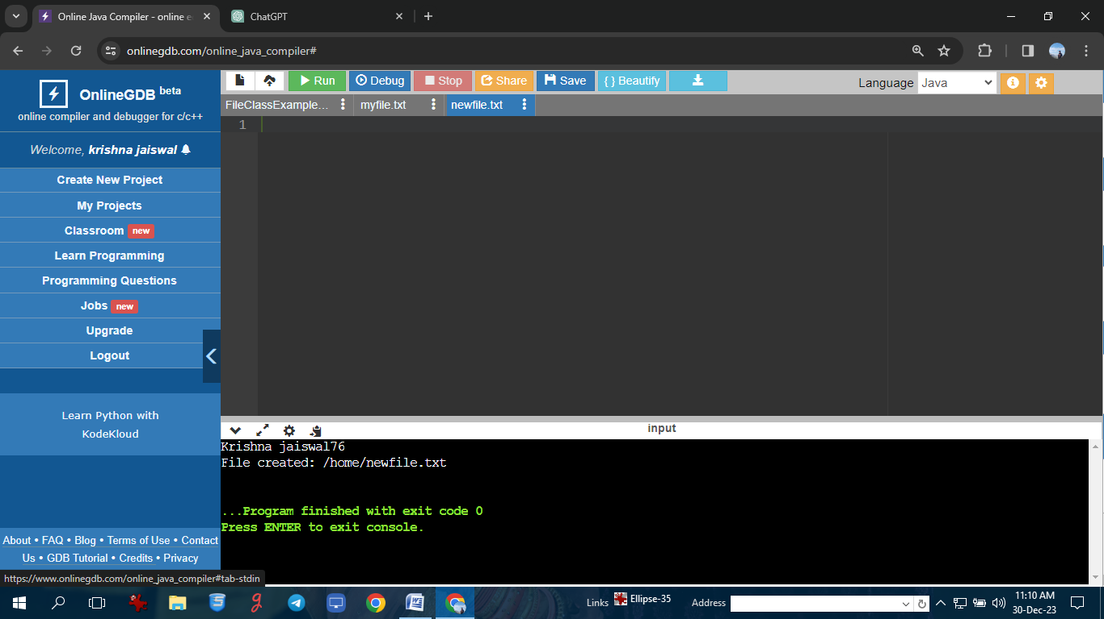

**: Program on File class.**

**Program: //Krishna jaiswal76**

import java.io.File;

public class FileClassExample2 {

public static void main(String[] args) {

System.out.println("Krishna jaiswal76");

String directoryPath = "newdirectory";

File directory = new File(directoryPath);

if (directory.mkdir()) {

System.out.println("Directory created: " + directory.getAbsolutePath());

} else {

System.out.println("Directory already exists or creation failed.");

}

}

}

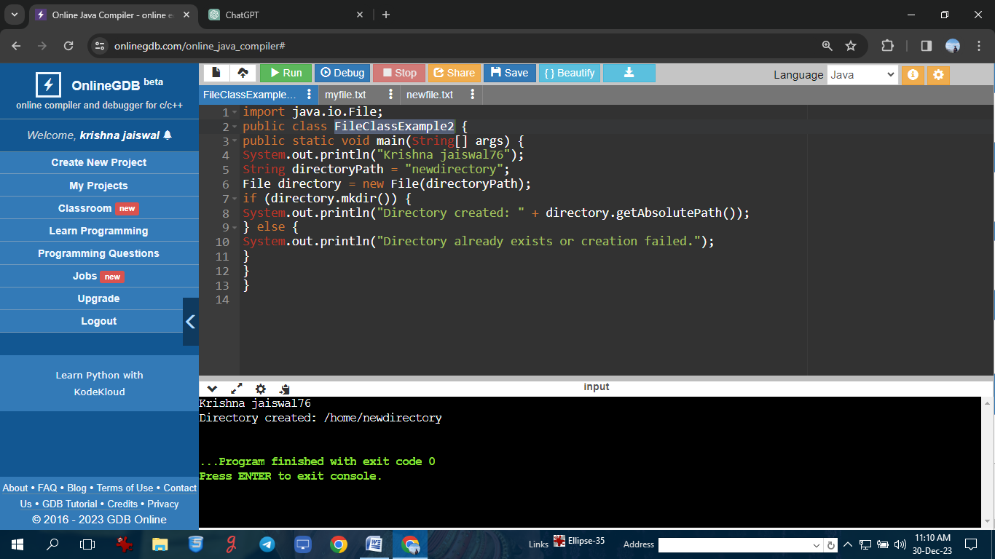

**Program on writing to file using FileOutputStream.**

**Program: //Krishna jaiswal76**

import java.io.FileOutputStream;

import java.io.IOException;

public class FileOutputStreamExample1 {

public static void main(String[] args) {

System.out.println("Krishna jaiswal76");

String filePath = "output.txt";

try (FileOutputStream fos = new FileOutputStream(filePath)) {

String text = "Hello, this is a sample text.\nWriting to a file in Java.";

fos.write(text.getBytes());

System.out.println("Text written to the file: " + filePath);

} catch (IOException e) {

e.printStackTrace();

}

}

}

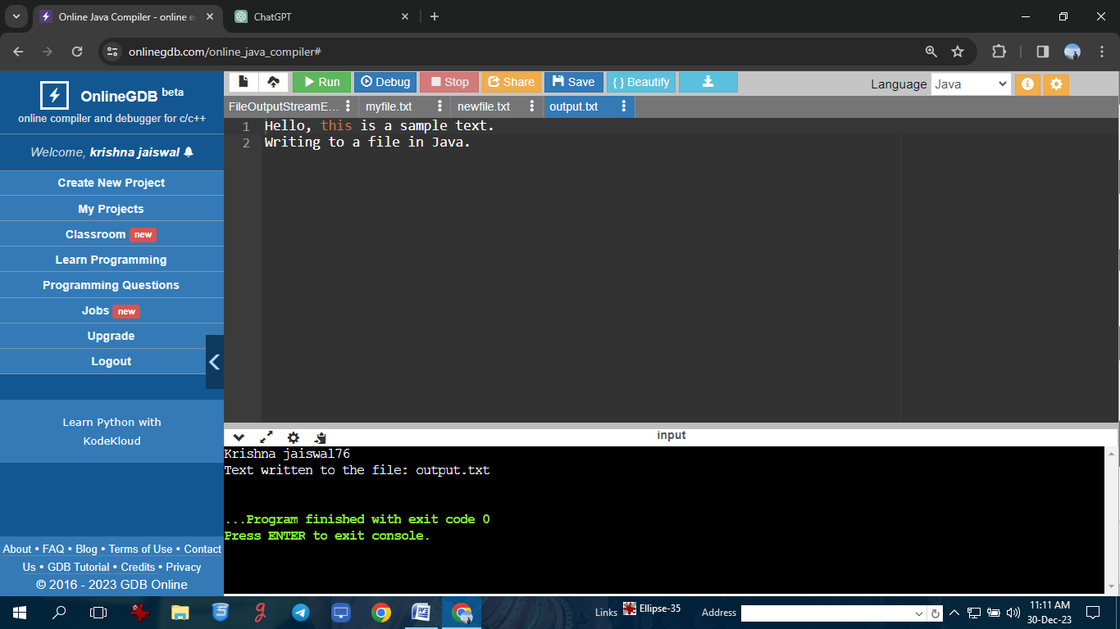

**Program on writing to file using FileOutputStream.**

**Program: //Krishna jaiswal76**

import java.io.FileOutputStream;

import java.io.IOException;

public class FileOutputStreamExample2 {

public static void main(String[] args) {

System.out.println("Krishna jaiswal76");

String filePath = "binaryoutput.dat";

try (FileOutputStream fos = new FileOutputStream(filePath)) {

int data1 = 123;

int data2 = 456;

fos.write(intToBytes(data1));

fos.write(intToBytes(data2));

System.out.println("Binary data written to the file: " + filePath);

} catch (IOException e) {

e.printStackTrace();

}

}

private static byte[] intToBytes(int value) {

return new byte[]{

(byte) (value >> 24),

(byte) (value >> 16),

(byte) (value >> 8),

(byte) value

};

}

}

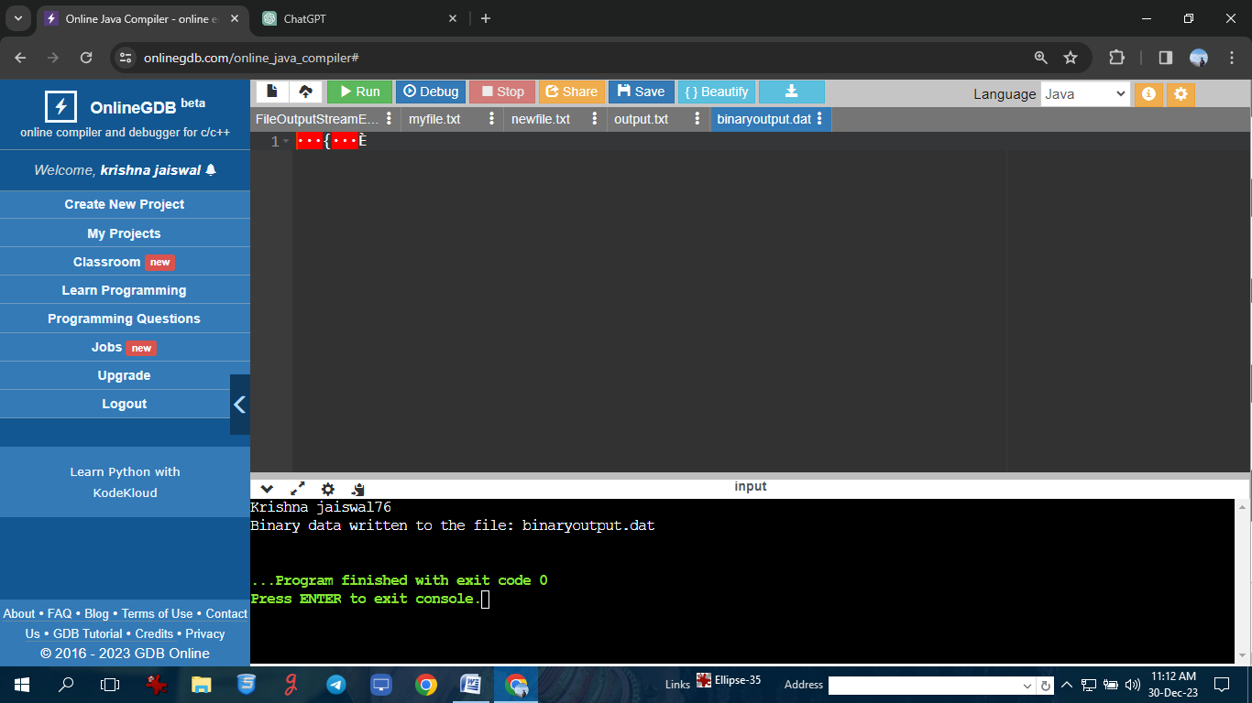

**Program on Reading from a file using FileInputStream.**

**Program: //Krishna jaiswal76**

import java.io.FileInputStream;

import java.io.IOException;

public class FileInputStreamExample1 {

public static void main(String[] args) {

System.out.print("Krishna jaiswal76");

String filePath = "input.txt";

try (FileInputStream fis = new FileInputStream(filePath)) {

int data;

while ((data = fis.read()) != -1) {

System.out.print((char) data);

}

} catch (IOException e) {

e.printStackTrace();

}

}

}

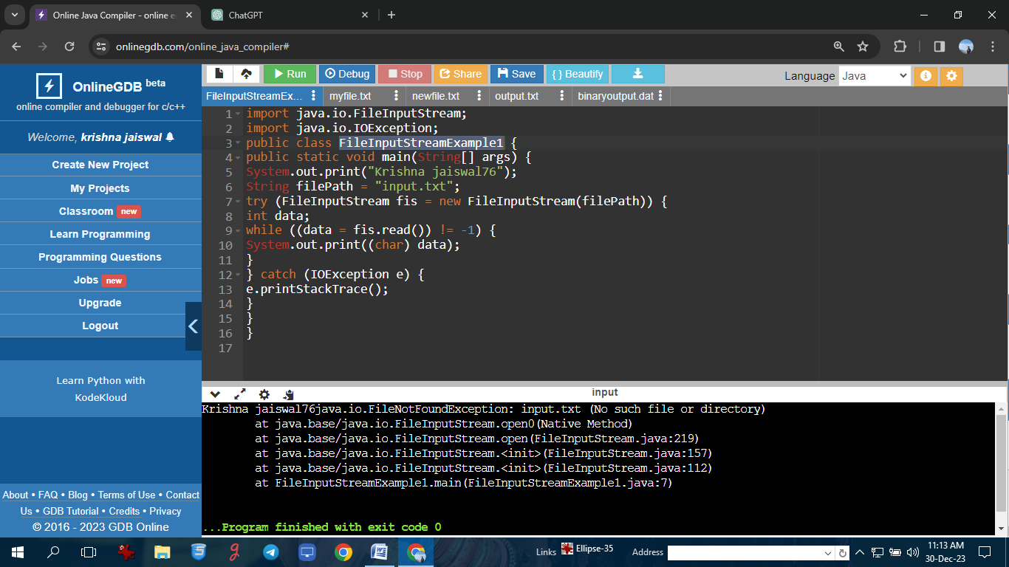

**Program on Reading from a file using FileInputStream.**

**Program: //Krishna jaiswal76**

import java.io.FileInputStream;

import java.io.IOException;

public class FileInputStreamExample2 {

public static void main(String[] args) {

System.out.println("Krishna jaiswal76");

String filePath = "binaryinput.dat";

try (FileInputStream fis = new FileInputStream(filePath)) {

byte[] buffer = new byte[4];

int bytesRead = fis.read(buffer);

if (bytesRead == 4) {

int data1 = bytesToInt(buffer);

System.out.println("Read data 1: " + data1);

}

bytesRead = fis.read(buffer);

if (bytesRead == 4) {

int data2 = bytesToInt(buffer);

System.out.println("Read data 2: " + data2);

}

} catch (IOException e) {

e.printStackTrace();

}

}

private static int bytesToInt(byte[] bytes) {

return (bytes[0] << 24) | ((bytes[1] & 0xFF) << 16) | ((bytes[2] & 0xFF) << 8) |

(bytes[3] & 0xFF);

}

}

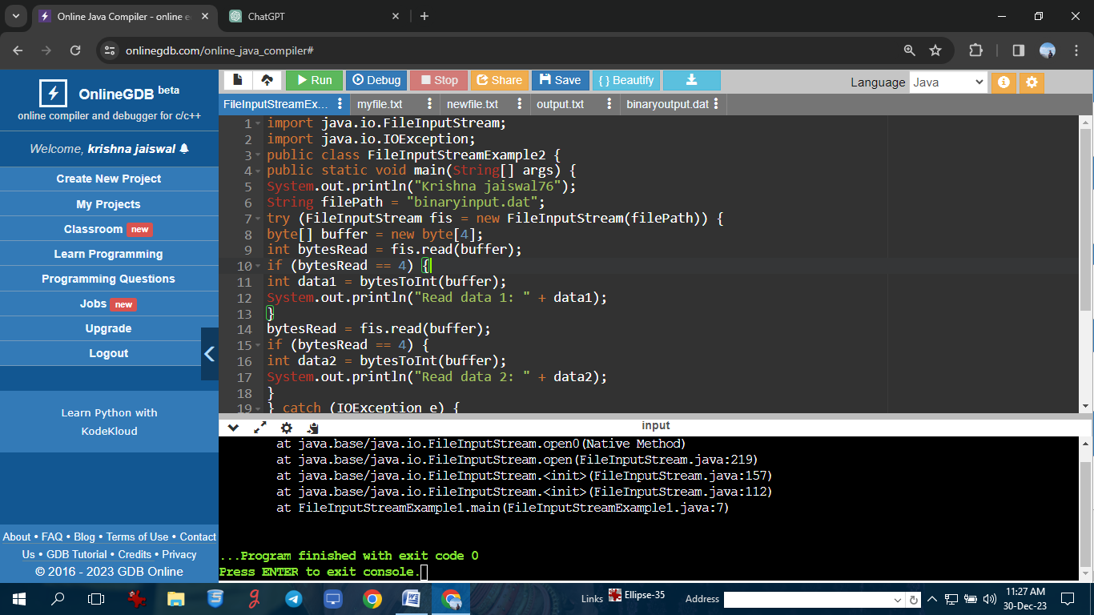

**Program on Finalize method.**

**Program: //Krishna jaiswal76**

public class FinalizeExample {

public static void main(String[] args) {

System.out.println("Krishna jaiswal76");

MyClass obj = new MyClass();

obj = null;

System.gc();

}

}

class MyClass {

@Override

protected void finalize() throws Throwable {

try {

System.out.println("Object is being finalized.");

} finally {

super.finalize();

}

}

}

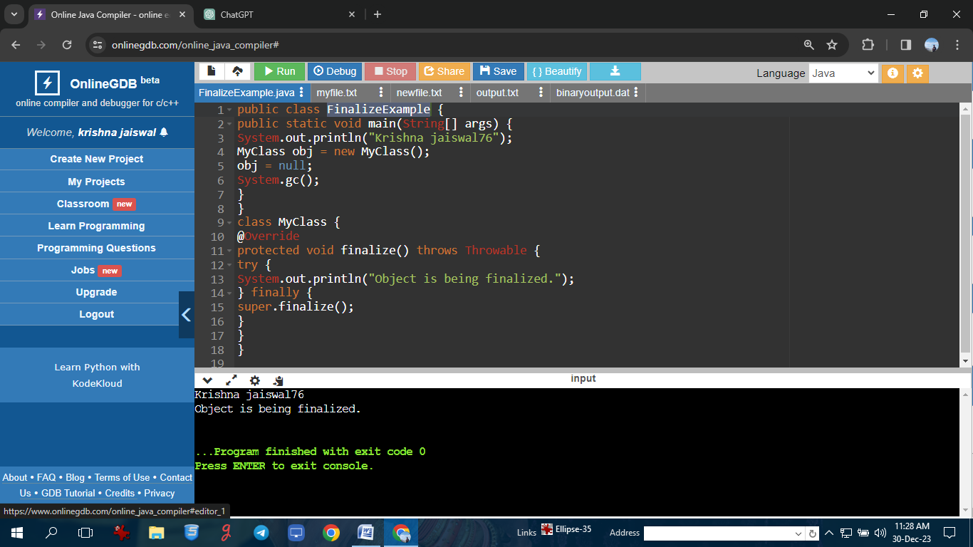

**Program on Garbage Collection.**

**Program: //Krishna jaiswal76**

public class TestGarbage1

{

public void finalize(){

System.out.println("Krishna jaiswal76");

System.out.println("object is garbage collected");

}

public static void main(String args[]){

TestGarbage1 s1=new TestGarbage1();

TestGarbage1 s2=new TestGarbage1();

s1=null;

s2=null;

System.gc();

}

}

